System Design
- Reliability in System Design
Reliability in system design refers to the ability of a system to consistently deliver correct and expected performance over time, even under varying conditions or stress. It focuses on maintaining stable operation and reducing unexpected disruptions.
- System reliability refers to how consistently a system performs its intended functions without failure over a given period under specified operating conditions.
- It means the system can be trusted to work correctly, even under stress or in different conditions.
- A reliable system minimizes downtime, handles errors smoothly, and provides consistent performance to users.
Example: In an online banking system, reliability ensures that transactions are processed correctly every time without data loss or system crashes.
Factors That Affect Reliability
Several factors influence the reliability of a system. These factors determine how consistently a system can perform without failures.
- Design Quality: Poor system design or lack of proper planning can lead to frequent failures and unstable performance.
- Hardware Quality: Low-quality components or hardware wear and tear can cause system breakdowns.
- Software Bugs: Errors in the code can lead to crashes, incorrect outputs, or unexpected behavior.
- Maintenance: Lack of regular updates, monitoring, and testing can reduce system reliability.
- Workload: Overloading the system beyond its capacity can slow it down or cause failures.
- External Conditions: Environmental factors like heat, power failures, or network issues can affect performance.
- Redundancy: Without backup systems or failover mechanisms, the system becomes more prone to downtime.
Ways to Improve System Reliability
These approaches help systems remain stable, reduce failures, and maintain consistent performance under different conditions.

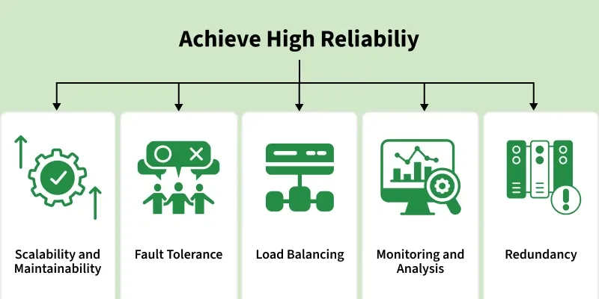
- Scalability and Maintainability: It ensure the system continues to work efficiently as it grows and evolves over time.
- Fault Tolerance: It enables the system to detect errors and recover automatically without failure.
- Load Balancing: It is used to distributes traffic across systems to avoid overload and handle high demand smoothly.
- Monitoring and Analytics: Monitoring and analytics track performance and help detect issues early.
- Redundancy: Remove duplicates critical components so the system keeps running even if one fails.
Differences between Reliability and Availability
Some of the differences between reliability and availability are:
Reliability | Availability
Reliability is the ability of a system to perform its intended functions correctly for a specific period without failure. | Availability is the percentage of time a system remains operational and accessible to users.
It focuses on failure-free operation over a period. | It focuses on whether the system is working at a specific moment.
Measured using metrics like Mean Time Between Failures (MTBF) and Mean Time to Repair (MTTR). | Measured as uptime percentage, such as 99%, 99.9%, or 99.99%.
It is considered a long-term measure of system performance and stability. | It is often considered a short-term measure of system accessibility.
A reliable system fails less frequently. | A highly available system recovers quickly from failures.
Focuses on reducing system failures through good design and quality components. | Focuses on minimizing downtime using redundancy and failover mechanisms.
Example: A database that rarely crashes over months is considered reliable. | Example: A website that quickly recovers after a server crash is considered highly available.

Ways to Measure Reliability
Here’s how reliability can be measured with formulas for better clarity:
1. Uptime Percentage
This metric measures the percentage of time a system remains operational during a specific period.
Uptime Percentage = ((Total Time - Downtime) / Total Time) * 100
Example: If a system was down for 2 hours in a week (168 hours), uptime will be:
Uptime = ((168-2)/168) * 100 = 98.81%
2. Mean Time Between Failures (MTBF)
MTBF indicates the average time a system operates before experiencing a failure.
MTBF = (Total Operational Time / Number of Failures)
Example: If a system runs for 1000 hours and fails 5 times, MTBF will be:
MTBF = (1000/5) = 200 hours
3. Mean Time to Repair (MTTR)
MTTR measures the average time required to repair a system and restore it to normal operation after a failure.
MTTR = Total Repair Time / Number of Failures
​Example: If the system took 10 hours to repair 5 failures, MTTR will be:
MTTR = 10/5 = 2 hours
4. Error Rate
Error rate shows the percentage of operations or transactions that result in errors.
Error Rate = (Number of Errors / Total Transactions or Operations) * 100
Example: If there are 50 errors in 10,000 operations, Error rate will be:
Error Rate = (50/10000) × 100 = 0.5%.
These formulas help quantify reliability, making it easier to identify weak points and areas for improvement.
Reasons for System Failures
Systems can become unreliable when they experience frequent failures, poor performance, or unexpected disruptions. These issues often arise due to design flaws, resource limitations, or external factors affecting system stability.
- Poor System Design: Inadequate architecture or lack of proper planning can lead to unstable systems and frequent failures.
- Hardware Failures: Physical components such as servers, disks, or network devices may fail over time due to wear and tear.
- Software Bugs: Errors in the application code or configuration can cause crashes, incorrect outputs, or unexpected behavior.
- Overloaded Systems: When systems handle more traffic or workload than they are designed for, performance may degrade or services may fail.
- Network Issues: Slow or unstable network connections can interrupt communication between system components.
- Lack of Monitoring and Maintenance: Without proper monitoring, updates, and regular maintenance, small issues can grow into major system failures.
- Single Point of Failure (SPOF): If a critical component fails and no backup is available, the entire system may stop functioning.

Single Point of Failure (SPOF)
A Single Point of Failure (SPOF) is a component in a system whose failure can cause the entire system to stop working. Systems that require high availability must avoid SPOFs to maintain reliability and continuous operation.
- A single failure in a critical component can disrupt the entire system.
- SPOFs reduce system reliability and increase the risk of downtime.
- Eliminating SPOFs improves system resilience and stability.
- Redundancy is commonly used to prevent failures from affecting the entire system.
Ways to Avoid Single Point of Failure (SPOF)
Avoiding single points of failure is important for building reliable and resilient systems. The following strategies can help eliminate SPOFs:
- Redundancy: Duplicate critical components so that backup systems can take over if one component fails.
- Load Balancing: Distribute workloads across multiple servers to prevent overloading a single component.
- Failover Mechanisms: Automatically switch to backup systems when the primary system fails.
- Regular Testing: Conduct stress testing and failure simulations to detect weaknesses early.
- Monitoring and Alerts: Continuously monitor system health and receive alerts when issues occur.
- Proper Documentation: Maintain clear documentation to help engineers quickly troubleshoot and resolve problems.
- Continuous Improvement: Regularly update and improve system architecture using best practices.
- Scalability in System Design
Scalability refers to a system’s ability to handle increasing workloads, users, or data without affecting performance. A scalable system can expand resources such as servers, storage, or processing power when needed.
- When a system's workload or scope rises, it should be able to maintain or even improve its performance, efficiency, and dependability. This is known as scalability.
- A system must be scalable to accommodate growing user traffic, data volumes, or computing demands without suffering a major performance hit or necessitating a total redesign.
Example: A video streaming platform that automatically adds more servers when millions of users start watching content at the same time.
Real-World Examples of Scalable Systems
There are many real-world examples of scalable systems that demonstrate the importance and impact of scalability in modern technology.
- Google: Uses a highly scalable distributed system (Bigtable, MapReduce, Spanner) to handle billions of searches globally.
- AWS: Offers scalable cloud services that let businesses easily scale compute, storage, and databases on demand.
- Netflix: Relies on cloud infrastructure, microservices, and caching to stream content to millions of users at once.
These examples highlight how scalability helps companies deliver reliable performance, handle traffic spikes, and grow rapidly without infrastructure limitations.
Ways to Achieve Scalability
These are common approaches used to handle increasing load and improve system performance efficiently.
1. Make It Bigger
Vertical Scaling, Like upgrading a car with a bigger engine for more power.
- Upgrading a system by adding more CPU, memory, or storage to a single server, like increasing a car’s engine power.
- Suitable for small applications and quick scaling but limited by hardware constraints and cannot scale indefinitely.
2. Get More Cars
Horizontal Scaling, Like using multiple cars to share the workload.
- Scaling by adding multiple servers or instances to share the workload, like using multiple cars instead of one.
- Distributes traffic across resources efficiently, making it ideal for large-scale applications with high user demand.
3. Divide and Conquer
Microservices, Treats the app as small, independent services.
- Breaks the application into small, independent services that handle specific functionalities.
- Allows scaling of only required parts, improving flexibility and efficient resource utilization.
4. No Servers, No Problems
Serverless, Removes the need to manage servers.
- Automatically scales based on demand without requiring manual server management.
- Cost-efficient for variable workloads, with services like AWS Lambda handling execution and scaling.
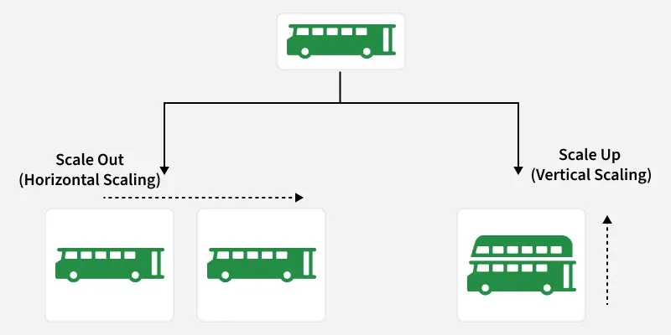
Factors Affecting Scalability
The factors that affect the scalability with their explanation are:
1. Performance Bottlenecks
Performance bottlenecks are components or processes in a system that limit overall performance and slow down operations.
- Performance bottlenecks are parts of a system that slow down overall performance.
- They are often caused by slow databases, inefficient code, or limited resources.
2. Resource Utilization
Efficient use of system resources is important to maintain performance and support system scalability.
- Efficiently using resources such as CPU, memory, and disk space is essential for scalability.
- Inefficient resource utilization can lead to bottlenecks and limit the system's ability to scale.
3. Network Latency
Network latency refers to the delay that occurs when data travels between systems or network nodes.
- Network latency is the delay in data transmission.
- High latency slows node communication and affects scalability.
4. Data Storage and Access
The way data is stored and accessed plays a major role in determining how well a system can scale.
- Data storage and access patterns affect scalability.
- Distributed databases and caching help systems scale better.
5. Concurrency and Parallelism
Concurrency and parallelism allow systems to process multiple tasks at the same time to improve performance.
- Enables handling of multiple tasks simultaneously, improving scalability and system efficiency.
- Increases throughput by processing more requests but may introduce latency due to synchronization and overhead if not managed properly.
6. System Architecture
System architecture determines how components are structured and how easily the system can scale.
- System architecture defines how easily a system can scale, with modular and loosely coupled components improving flexibility.
- Supports both horizontal scaling (adding instances) and vertical scaling (upgrading resources) for better performance.
Components that help to increase Scalability
Some of the main components that help to increase the scalability are:
- Load Balancer: A load balancer distributes incoming traffic across multiple servers to avoid overload and improve performance and availability.
- Caching: Caching stores frequently accessed data temporarily to reduce latency and backend load.
- Database Replication: Database replication creates multiple copies of data (often asynchronously) to improve availability and read performance, with trade-offs in consistency.
- Database Sharding: Database sharding splits data into smaller shards to scale databases across multiple instances.
- Microservices Architecture: Microservices architecture divides applications into independent services that can scale separately.
- Data Partitioning: Data partitioning divides data based on criteria like user or region to improve scalability.
- Content Delivery Networks (CDNs): CDNs deliver cached content from locations closer to users, reducing latency.
- Queueing Systems: Queueing systems handle requests asynchronously to manage traffic spikes and prevent overload.
Challenges and Trade-offs in Scalability
Challenges and trade-offs include:
- Cost Vs Scalability: Scaling improves performance and availability but often increases infrastructure and operational costs.
- Complexity: As systems scale, they become harder to manage, maintain, and debug, raising operational overhead.
- Latency Vs Throughput: There is often a trade-off between latency and throughput. Optimizing for low latency may reduce throughput, and vice versa.
- Data Partitioning Trade-offs: Partitioning boosts scalability but requires careful balance of partition size, data movement, and data locality.
- Maintainability in System Design
Maintainability refers to how easily a software system can be modified, updated, or improved over time. It ensures developers can fix issues, add features, and enhance components with minimal disruption to the system.
- The system is structured into smaller modules so individual parts can be changed without affecting the entire application.
- Clear, readable code along with version control and automated testing helps track changes and quickly detect issues.
Example: In a large web application, developers organize the system into separate modules such as authentication, payment, and user management. This allows teams to update one module without impacting the rest of the application.
Measuring Maintainability
While measuring maintainability is subjective, here are some metrics to measure it:
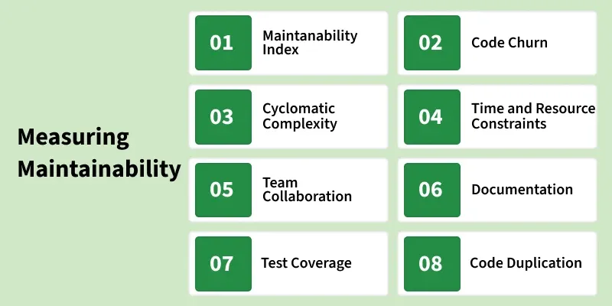
1. Maintainability Index
It gives a score to measure how maintainable a code module or system is. It considers factors like complexity and duplication and may vary by IDE. A higher score means better maintainability and easier code improvements.
2. Code Churn
It tracks how often a code module is modified over time using version control data. High churn can indicate instability, while monitoring it helps identify areas needing extra testing and attention.
3. Cyclomatic Complexity
It measures the complexity of a code module. Higher complexity is an indication that the code is more complicated to understand and there may be potential easier ways available to break the complexity of a particular code module.
4. Time and Resource constraints
It's important to balance between speed of development as well as speed of maintainability. A rush by the development team to complete a tight deadline without considering maintainability can lead to complicated future maintenance efforts.
5. Team Collaboration
A strong collaborative culture within the development team helps them share knowledge with each other, perform Knowledge Transfer programs (KT), mentor newcomers, and work together on maintenance tasks, it helps team members grow together and makes sure someone won't struggle in doing a particular task.
6. Documentation
A Good documentation is the one, which makes a newcomer understand the project and covers not only code comments but also architectural decisions, System design, API references, as well.
7. Test Coverage
It measures the extent to which automated tests cover the codebase, it helps prevent regressions from being introduced. Test coverage tools assess the extent of code exercised by automated tests, expressed as a percentage.
8. Code Duplication
It measures how much-repeated code exists in a system. High duplication increases maintenance effort because changes must be updated in multiple places. It is detected using static analysis tools that find similar code segments.
Hidden Costs of Poor Maintainability
Poor maintainability makes systems harder to understand and modify, reducing efficiency and stability. It increases development time and complexity, slowing down the delivery of new features.
- Increase in Technical Debt: Quick fixes and temporary solutions accumulate over time, making the codebase more complex and harder to manage.
- Slower Bug Fixing: Developers may spend significant time understanding complicated code before resolving issues.
- Difficult Test Maintenance: Automated tests may frequently break when the underlying code is poorly structured or tightly coupled.
- Delayed Development Cycles: Poor maintainability can slow down feature development and make meeting project deadlines challenging.
- Unreliable Testing: Poorly organized code makes it difficult to create stable and effective test cases.
Ways to achieve high Maintainability
Designing a highly maintainable system requires a proactive approach during the development process. Here are some strategies to achieve and improve maintainability in system design:
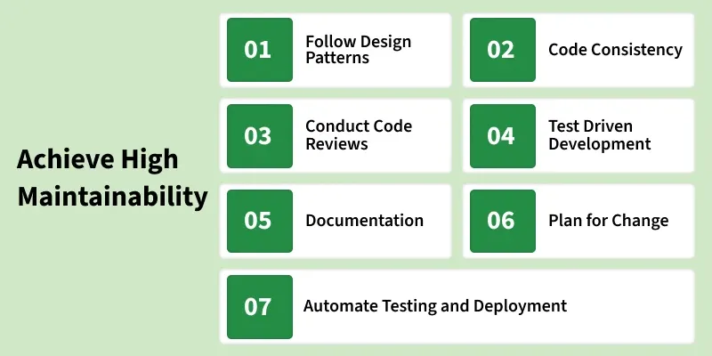
1. Follow Design Patterns
Design patterns, such as Model-View-Controller and SOLID principles, promote modularity, and flexibility. Following these patterns enhances overall architecture while making it easier to maintain.
2. Code Consistency
Well-written, readable code with meaningful variables, comments, and documentation makes maintenance tasks even smoother. So, as much as possible while writing code or documentation make it simple in design and implementation.
3. Conduct Code Reviews
Code reviews by peers and maintainers help identify potential issues early while ensuring that code adheres to maintainability standards and coding style guidelines.
4. Test-Driven Development (TDD)
Adopting TDD ensures that test cases are written before the code implementation, helping developers understand the codebase easily while troubleshooting an issue.
5. Documentation
Good documentation reduces the learning curve for new Devs and helps the existing team understand it better during maintenance. Maintain thorough documentation of the system's architecture, APIs, modules, and dependencies.
6. Plan for Change
Design the system in such a way, that makes it easier to add new features and adapt to evolving requirements of daily enhancements.
7. Automate Testing and Deployment
Automating testing and deployment reduces the chance of human error and helps maintain system stability during updates, while also saving time and effort for the team.
Challenges in Maintainability
Maintaining a large software system can become difficult as the system grows in size and complexity. Various technical and organizational factors can reduce maintainability and make updates or bug fixes more time-consuming.
• Complex Code Structure: Highly complex or tightly coupled code makes it difficult for developers to understand and modify the system.
• Poor Documentation: Lack of proper documentation makes it harder for new developers to understand system architecture and functionality.
• Frequent Requirement Changes: Continuous changes in requirements can make the system harder to maintain if the design is not flexible.
• Code Duplication: Repeated code across different modules increases maintenance effort because changes must be applied in multiple places.
• Lack of Automated Testing: Without proper testing, even small changes may introduce new bugs, making maintenance risky.
• Technical Debt: Quick fixes or temporary solutions added over time can make the system harder to manage and update.
System Design Life Cycle (SDLC)
The System Design Life Cycle (SDLC) is a structured process used to plan, design, develop, test, deploy, and maintain software systems. It helps teams build reliable, scalable, and high-quality systems by following well-defined phases, ensuring that business requirements are correctly translated into technical solutions.
- Provides a clear roadmap from idea to deployment.
- Improves project planning, tracking, and control.
- Ensures better quality through systematic testing.
- Reduces development risks and cost overruns.
- Enhances collaboration between stakeholders and developers.
- Makes systems easier to maintain and scale over time.
Below are the objective and example of each stage of System Design Life Cycle:
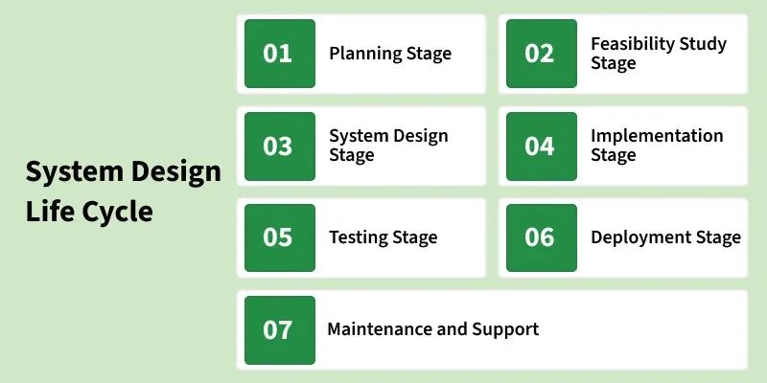
[Stage 1]: Planning
- This is where the project starts! You decide what you want to achieve (goals), how much you can spend (budget), and who will work on it (team).
Example: A company plans to build a customer management system and outlines its key features and the team involved.
[Stage 2]: Feasibility Study
- Before starting, check if the idea is practical. Will it work technically? Is it affordable?
Example: The company checks if building the system is worth the cost and effort and whether it can deliver the expected benefits.
[Stage 3]: System Design
- This stage is all about planning how the system will work behind the scenes and how it will look to users.
- Imagine designing a house, before construction begins, architects create blueprints that show where every room, pipe, and wire will go. Similarly, in system design, you create a detailed plan that developers will follow to build the system.
[Stage 4]: Implementation
- Transform the design into an operational system. Developers write the code to create the system based on the design.
Example: The CRM system's features, like customer profiles and dashboards, are coded
[Stage 5]: Testing
- Verify that the system meets the specified requirements and makes sure everything works as planned.
- The CRM system undergoes various testing procedures, such as unit testing, integration testing, and user acceptance testing, to ensure its functionality, performance, and security.
[Stage 6]: Deployment
- All the hard work concludes at the deployment phase, when the system is made accessible for real usage. After all the planning, designing, and building is finished, it's similar like launching a new store.
- This stage involves transferring the system from a testing or development environment to a production environment where actual users can access it.
[Stage 7]: Maintenance and Support
- Ensure the ongoing functionality and address any issues that arise.
- Regular updates, bug fixes, and user support for the CRM system to adapt to changing business requirements and address any emerging issues.
Differences between the System Development Life Cycle and the System Design Life Cycle
Below are the differences between System Development Life Cycle and System Design Life Cycle:
Aspect | System Development Life Cycle | System Design Life Cycle
Definition | A comprehensive framework covering the entire system development process. | A subset of the SDLC that specifically deals with designing the system.
Scope | Encompasses the entire life cycle of a system, form initiation to retirement. | Focuses primarily on the design aspects of the system.
Phases | Typically includes Planning, Analysis, Design, Implementation, Testing, Deployment, and Maintenance. | Usually includes Feasibility Study, System Analysis, System Design, Implementation, Testing, Deployment, and Maintenance.
Focus | Broad focus on the overall development process, addressing planning, implementation, testing, and maintenance. | Specific focuses on the design phase, detailing how the system will be built and operate.
Purpose | Guides the development team through the entire process, from concept to post-deployment support. | Provides a blueprint for constructing the system based on specified design requirements.
Challenges in System Design Life Cycle
Below are the challenges in System Design Life Cycle:
- Sometime, the initial requirements for a system might be unclear or ambiguous, leading to difficulties in designing the system accurately.
- Requirements may change during the design process, posing a challenge to maintain consistency and ensuring that the system still meets the user's needs.
- Rapid advancements in technology can make it challenging to choose the most suitable and up-to-date technologies for system design.
- Ensuring seamless integration of various system components can be complex, especially when dealing with different technologies and platforms.
- Designing a system within budgetary constraints can be challenging, as incorporating certain features or technologies might be cost-productive.
Models Used for System Design Life Cycle
Below are the models used for System Design Life Cycle:
- Waterfall Model: A linear and sequential model where each phase must be completed before moving on to the next. It's a straightforward approach but can be inflexible in the face of changing requirements.
- Iterative Model: Involves repeating cycles, with each iteration refining and improving the system based on feedback. It's adaptable to changing requirements.
- Prototyping Model: Involves building a prototype (a preliminary version) of the system to gather feedback refine the design before building the final product.
- Spiral Model: Incorporates elements of both iterative and prototyping models. It involves cycles of planning, designing, constructing, and evaluating.
- Agile Model: Emphasizes flexibility and collaboration, with frequent iterations and continuous feedback. It's well suited for projects where requirements may evolve.
Iterative Nature of SDLC
The iterative nature of the System Design Life Cycle (SDLC) means the process is not strictly linear; instead, it involves revisiting and refining stages based on feedback and evolving requirements. This ensures the system remains adaptable and aligned with its objectives.
Key Aspects of Iteration in SDLC:
- Refining Requirements: Stakeholders may identify additional needs or changes after deployment or testing. These insights prompt revisiting earlier phases, such as planning or design, to incorporate updates.
- Prototyping and Testing: Prototypes or early iterations of the system are developed and evaluated. Better performance and user satisfaction are ensured by improving the design and implementation based on feedback from these trials.
- Adapting to Changes: The system design is reviewed and modified to be relevant and efficient as user expectations, technological advancements, or corporate objectives change.
The system may gradually evolve to satisfy present and future expectations due to this iterative process, which also ensures ongoing improvement and reduces risks. It's similar to building a bridge and then modifying it over time to handle growing traffic or changing conditions.
Best Practices in System Design Life Cycle
Below are the best practices in System Design Life Cycle:
- Invest time in thoroughly understanding and documenting requirements to provide a solid foundation for the design process.
- Maintain open communication with stakeholders to ensure their needs are understood and to address any changes promptly.
- Design systems in a modular fashion, allowing for easier maintenance, updates, and scalability.
- Identify potential risks early in the design process and develop strategies to mitigate or manage them effectively.
Use Cases of System Design Life Cycle
The SDLC is used in a wide variety of projects, from developing small applications to building large enterprise systems. Some common use cases for the SDLC includes:
- Developing new software applications.
- Enhancing existing software applications.
- Integrating different systems together.
- Replacing legacy systems.
- Developing custom solutions for specific business needs.
By following the best practices and using the appropriate SDLC model, organizations can increase their chances of successfully completing their system development projects.
Functional and Non-Functional Requirements
Requirements analysis is a crucial phase in software development where the needs and expectations of users and stakeholders are identified and documented. It ensures the system is built correctly and meets its intended goals.
- Functional Requirements: Define what the system should do (features and operations).
- Non-Functional Requirements: Define how the system should perform (quality, performance, and constraints).
Example: In an online shopping system, functional requirements include features like user login and order placement, while non-functional requirements include system performance, security, and scalability.
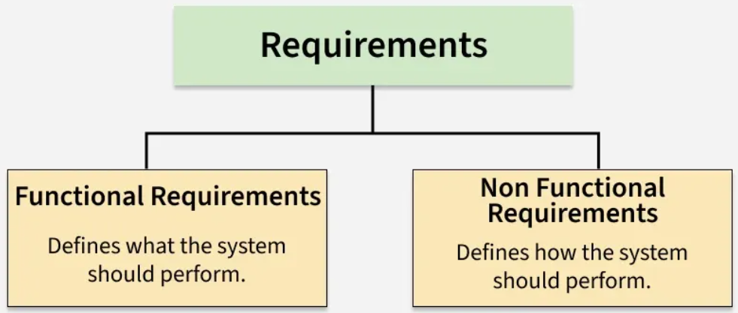
Functional Requirements
Functional requirements define the specific features and operations a system must perform to meet business and user needs. They describe what the system should do and how it interacts with users or other systems.
- Focus on the behavior and functionality of the system.
- Represent features that can be directly observed and tested in the final product.
- Examples include user authentication, data processing, search functionality, payment processing, and report generation.
Sample Questions
- What features should the system include?
- What edge cases or special scenarios should the system handle?
Non-Functional Requirements
Non-functional requirements (NFRs) define how a system should operate, focusing on performance, reliability, and user experience rather than specific features. They ensure the system is efficient, secure, and maintainable over time.
- Performance: speed and responsiveness
- Security: protection against unauthorized access
- Usability: ease of use
- Reliability: system stability and availability
- Scalability: ability to handle growth
- Maintainability: ease of updates and fixes
- Portability: ability to run in different environments
Sample Questions
- How fast should the system respond to user actions?
- How secure should it be against unauthorized access?
- How available and reliable should the system be?
Extended Requirements
Extended requirements define additional capabilities or considerations that enhance the system but are not part of the core functional features. These requirements help improve monitoring, reliability, and future expansion of the system.
- Logging: recording system activities and errors for debugging and analysis
- Monitoring & Alerting: tracking system health, performance, and failures
- Analytics: collecting usage data to understand user behavior and system performance
- Backup & Disaster Recovery: ensuring data can be restored in case of failures
- Rate Limiting: controlling the number of requests to prevent system overload or abuse
- Feature Flags / A-B Testing: enabling controlled feature releases and experiments
Sample Questions
- How will the system be monitored and alerted if failures occur?
- How will logs and analytics be collected for debugging and insights?
- How will the system recover from failures or data loss?
Examples of Functional and Non-functional Requirements
A couple of examples to illustrate both types of requirements:
1. Online Banking System
Functional Requirements:
- Users should be able to log in with their username and password.
- Users should be able to check their account balance.
- Users should receive notifications after making a transaction.
Non-functional Requirements:
- The system should respond to user actions in less than 2 seconds.
- All transactions must be encrypted and comply with industry security standards.
- The system should be able to handle 100 million users with minimal downtime.
Extended Requirements:
- The system should log all transactions for auditing and fraud detection.
- The system should have automatic backups and disaster recovery mechanisms.
- The system should include monitoring and alerts to detect unusual activities.
2. Food Delivery App
Functional Requirements:
- Users can browse the menu and place an order.
- Users can make payments and track their orders in real time.
Non-functional Requirements:
- The app should load the restaurant menu in under 1 second.
- The system should support up to 50,000 concurrent orders during peak hours.
- The app should be easy to use for first-time users, with an intuitive interface.
Extended Requirements:
- The system should collect analytics on popular dishes and order trends.
- The system should include monitoring and logging to track errors and performance.
- The system should support A/B testing for new features like promotions or UI changes.
Differences between Functional Requirements and Non-Functional Requirements
Functional Requirements | Non-Functional Requirements
Define what the system should do (features & functionality) | Define how the system should perform (quality attributes)
Focus on system behavior and operations | Focus on performance, usability, security, reliability
Describe specific actions like login, data processing, transactions | Describe constraints like response time, scalability, availability
Directly visible to users and business needs | Indirectly visible, improve overall user experience
Easier to measure (output-based validation) | Harder to measure, uses metrics like SLAs, benchmarks
Drive the core functionality of the system | Influence architecture and system design decisions
Documented using use cases, user stories | Documented using technical specs, performance criteria
Examples: login authentication, data input/output, transaction processing. | Examples: scalability, security, response time, reliability, maintainability.
Common Challenges in Defining these Requirements
Defining system requirements can be challenging because they must balance functionality, performance, and long-term system goals. Poorly defined requirements can lead to design issues, delays, or systems that fail to meet user expectations.
- Ambiguity in Requirements: Vague or incomplete requirements make it difficult to clearly define what the system should do and how it should perform.
- Changing Requirements: Business goals, market conditions, or user expectations may change over time, requiring updates to the system design.
- Difficulty in Prioritization: Functional requirements often receive more attention, while important aspects like scalability, security, or monitoring may be overlooked.
- Measuring Non-Functional Requirements: Features are easier to test, but qualities like usability, scalability, and reliability are harder to measure and validate.
- Overlapping or Conflicting Requirements: Some requirements may conflict with others, such as strong security measures potentially affecting system performance.
Gathering Functional, Non-functional and Extended Requirements
Gathering requirements involves multiple approaches and collaboration between the development team, stakeholders, and end-users.
1. Functional Requirements
- Interviews: Talk to stakeholders or users to understand their needs.
- Surveys: Distribute questionnaires to gather input from a larger audience.
- Workshops: Host sessions to brainstorm features and gather feedback.
2. Non-functional Requirements
- Performance Benchmarks: Consult with IT teams to set expectations for performance and load.
- Security Standards: Consult with security experts to define the best practices for data protection.
- Usability Testing: Test the system to find areas where users might struggle and refine the interface.
3. Extended Requirements
Extended requirements are gathered to improve system monitoring, reliability, and future enhancements beyond the core functionality.
- Monitoring & Logging: Consult DevOps teams to determine how system logs, metrics, and alerts will be collected and analyzed.
- Analytics & Reporting: Work with product teams to decide what user behavior or system data should be tracked for insights.
- Backup & Disaster Recovery: Discuss with infrastructure teams to define backup strategies and recovery procedures.
- Rate Limiting & System Protection: Identify limits on API requests and traffic control to prevent abuse or overload.
- Feature Flags & Experiments: Coordinate with product teams to plan controlled feature releases and A/B testing.
Requirements Gathering
Requirements gathering is the process of collecting and understanding what a software system should do by working closely with stakeholders. It helps define features, expectations, and constraints so the final product aligns with business goals and user needs.
- Clarifies project objectives and expectations.
- Identifies stakeholder and user requirements.
- Defines system scope and boundaries.
- Reduces misunderstandings and rework.
- Helps in accurate planning and estimation.
- Improves overall software quality.
Main Requirements Gathering Subprocesses
Requirements gathering is a critical phase in the software development lifecycle, and it involves several subprocesses to ensure a comprehensive understanding of the project's needs. The main sub-processes include:
Stakeholder Identification:
- Objective: Identify all stakeholders who will be affected by the system, directly or indirectly.
- Process: Conduct interviews, surveys, or workshops to determine the key individuals or groups involved.
Stakeholder Analysis:
- Objective: Understand the needs, expectations, and influence of each stakeholder.
- Process: Analyze stakeholder inputs to prioritize requirements and manage conflicting interests.
Problem Definition:
- Objective: Clearly define the problems or opportunities that the software system aims to address.
- Process: Engage stakeholders in discussions to uncover and articulate the core problems or opportunities.
Requirements Extraction:
- Objective: Gather detailed requirements by interacting with stakeholders.
- Process: Employ techniques such as interviews, surveys, observations, or brainstorming sessions to extract requirements.
Requirements Documentation:
- Objective: Document gathered requirements in a structured format.
- Process: Create requirements documents, use cases, user stories, or prototypes to capture and communicate requirements effectively.
Validation and Verification:
- Objective: Ensure that gathered requirements are accurate, complete, and consistent.
- Process: Conduct reviews, walkthroughs, or use validation tools to verify that the requirements meet the defined criteria.
Processes of Requirements Gathering in Software Development
There are 6 steps crucial for requirement gathering processes:
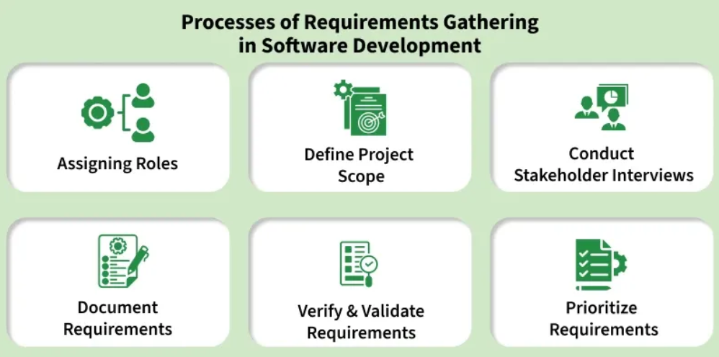
[Step 1]- Assigning roles:
- The first step is to identify and engage with all relevant stakeholders. Stakeholders can include end-users, clients, project managers, subject matter experts, and anyone else who has a vested interest in the software project. Understanding their perspectives is essential for capturing diverse requirements.
[Step 2]- Define Project Scope:
- Clearly define the scope of the project by outlining its objectives, boundaries, and limitations. This step helps in establishing a common understanding of what the software is expected to achieve and what functionalities it should include.
[Step 3]- Conduct Stakeholder Interviews:
- Schedule interviews with key stakeholders to gather information about their needs, preferences, and expectations. Through open-ended questions and discussions, aim to uncover both explicit and implicit requirements. These interviews provide valuable insights that contribute to a more holistic understanding of the project.
[Step 4]- Document Requirements:
- Systematically document the gathered requirements. This documentation can take various forms, such as user stories, use cases, or formal specifications. Clearly articulate functional requirements (what the system should do) and non-functional requirements (qualities the system should have, such as performance or security).
[Step 5]- Verify and Validate Requirements:
- Once the requirements are documented, it's crucial to verify and validate them. Verification ensures that the requirements align with the stakeholders' intentions, while validation ensures that the documented requirements will meet the project's goals. This step often involves feedback loops and discussions with stakeholders to refine and clarify requirements.
[Step 6]- Prioritize Requirements:
- Prioritize the requirements based on their importance to the project goals and constraints. This step helps in creating a roadmap for development, guiding the team on which features to prioritize. Prioritization is essential, especially when resources and time are limited.
Requirement Gathering Techniques:
Effective requirement gathering is essential for the success of a software development project. Various techniques are employed to collect, analyze, and document requirements.
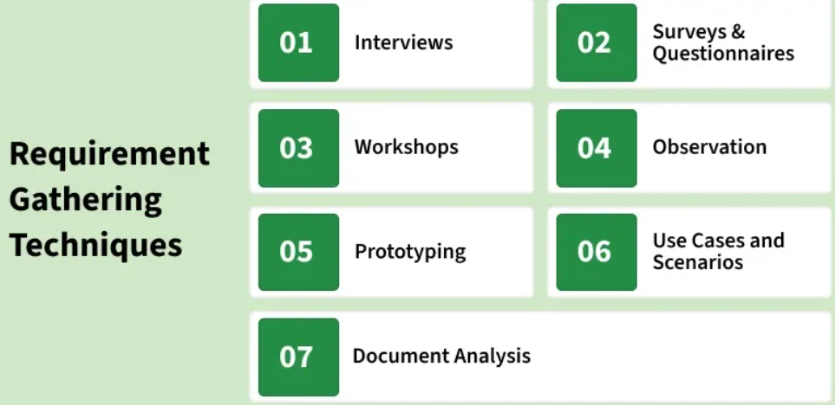
Here are some commonly used requirement gathering techniques:
- Interviews – One-on-one or group discussions with stakeholders to capture needs, expectations, and concerns.
- Surveys & Questionnaires – Collect large-scale feedback from diverse stakeholders, useful in big projects.
- Workshops – Collaborative sessions to define requirements, resolve conflicts, and generate ideas.
- Observation – Watching end-users in their environment to identify workflows, pain points, and hidden needs.
- Prototyping – Building mockups or prototypes for early feedback and refining requirements.
- Use Cases & Scenarios – Describing system interactions in real situations to identify functional needs.
- Document Analysis – Reviewing existing manuals, reports, and forms to extract process insights.
Why Requirement Gathering is important?
Requirement gathering holds immense importance in software development for several critical reasons:
- Clarity of Objectives – Defines project goals and ensures all stakeholders share the same vision.
- Customer Satisfaction – Captures user needs to build a product that meets expectations.
- Scope Definition – Establishes project boundaries, preventing scope creep and keeping work on track.
- Reduced Misunderstandings – Promotes clear communication, minimizing ambiguity and errors.
- Risk Mitigation – Identifies issues early to avoid costly rework, delays, and failures.
Benefits of Requirements Gathering:
The benefits of effective requirements gathering in software development include:
- Cost Reduction – Minimizes costly changes and rework by defining requirements clearly at the start.
- Customer Satisfaction – Ensures the product meets stakeholder expectations, enhancing trust and future collaboration.
- Improved Communication – Acts as a bridge between stakeholders, reducing misunderstandings and aligning vision.
- Efficient Resource Utilization – Enables accurate allocation of time, manpower, and technology.
- Enhanced Quality – Provides a foundation for quality assurance and effective testing strategies.
- Risk Management – Identifies potential risks early for proactive mitigation.
- Accurate Planning – Supports realistic schedules, milestones, and deliverables, keeping the project on track.
Common Obstacles in Software Requirements Gathering:
Common obstacles in software requirements gathering include:
- Unclear Objectives – Stakeholders unsure of goals can cause confusion and scope creep.
- Ambiguous Requirements – Vague or conflicting requirements lead to misunderstandings and rework.
- Poor Stakeholder Involvement – Missing input from key stakeholders risks incomplete requirements.
- Changing Requirements – Frequent changes (scope creep) cause delays, cost overruns, and focus loss.
- Communication Barriers – Misinterpretations or inadequate channels hinder clarity.
- Overreliance on Documentation – Solely using documents may miss context; interactive processes are needed.
- Lack of User Involvement – Ignoring end-users can result in unusable or unsatisfactory systems.
Requirements Gathering help in Agile Software Development
Agile development emphasizes flexibility, collaboration, and continuous improvement. The requirements gathering process in Agile is iterative and adaptive, allowing for changes and adjustments throughout the development lifecycle. Here's a detailed explanation of the requirements gathering process in Agile:
- User Stories: Requirements written from the user’s perspective.
- Product Backlog Refinement: Continuous prioritization and clarification.
- Iterative Development (Sprints): Incremental delivery and learning.
- Continuous Stakeholder Collaboration: Regular reviews and feedback.
- Prototyping & Visual Aids: Faster understanding and validation.
- Daily Stand-ups: Ongoing alignment and issue detection.
- Acceptance Criteria: Clear definition of “done”.
- Sprint Retrospectives: Improve requirement practices continuously.
Challenges and Considerations in Agile Requirements Gathering
- Changing Priorities: Agile embraces changes in requirements, but frequent changes can pose challenges. It's crucial to strike a balance between flexibility and stability, ensuring that changes are well-understood, prioritized, and communicated effectively to the development team.
- Balancing Detail and Flexibility: Agile requires enough detail to guide development, but also the flexibility to adapt as requirements evolve. Striking the right balance ensures that the team can respond to changes while maintaining a clear understanding of the project's direction.
- Effective Communication: Agile heavily relies on communication and collaboration. Ensuring that all team members, including stakeholders, have open channels for communication is essential to prevent misunderstandings and align everyone with the project's goals.
- Overemphasis on Documentation: While Agile values working software over comprehensive documentation, it's important to strike a balance. Minimal but effective documentation, such as user stories and acceptance criteria, should be maintained to ensure a shared understanding among team members and stakeholders.
- Ensuring Continuous Feedback: Agile places a strong emphasis on continuous feedback, but ensuring active stakeholder involvement can be challenging. Efforts should be made to encourage regular feedback through sprint reviews, demos, and other collaborative sessions to avoid potential misunderstandings and to keep the development aligned with stakeholder expectations.
By embracing these Agile practices and considering the associated challenges, teams can effectively gather and adapt requirements throughout the development process, delivering value to stakeholders in a dynamic and responsive manner.
Tools for Requirements Gathering in Software Development
Requirements gathering tools play a crucial role in streamlining the process of collecting, documenting, and managing project requirements. These tools are designed to enhance collaboration, improve communication, and facilitate the organization of complex information. Here are several types of requirements gathering tools and their roles:
- Collaboration Tools: Collaboration tools, such as project management platforms (e.g., Jira, Trello, Asana), facilitate teamwork and communication among project stakeholders. These platforms often include features like task assignment, progress tracking, and discussion forums, enabling teams to collaboratively gather, discuss, and manage requirements in real-time.
- Document Management Tools: Document management tools (e.g., Confluence, SharePoint) help organize and store project documentation. These tools provide a centralized repository for requirements, ensuring easy access, version control, and collaboration. Document management tools are particularly valuable for maintaining a structured record of evolving project requirements.
- Survey and Form Builders: Tools like Google Forms, Typeform, or SurveyMonkey enable the creation of online surveys and forms. These are useful for gathering structured data from a large audience, such as feedback, preferences, or specific information required for project requirements. The collected data can be easily analyzed and integrated into the requirements gathering process.
- Prototyping Tools: Prototyping tools (e.g., Sketch, Balsamiq, Figma) allow the creation of visual or interactive prototypes. These tools are valuable for translating requirements into tangible representations that stakeholders can interact with, providing a clearer understanding of the proposed features and functionalities.
- Mind Mapping Tools: Mind mapping tools (e.g., MindMeister, XMind) help visualize and organize complex ideas and relationships. During requirements gathering, these tools can be used to create visual representations of interconnected requirements, helping stakeholders and the project team understand the relationships between different features and functionalities.
- Version Control Systems: Version control systems (e.g., Git, SVN) are essential for managing changes to project documentation. These tools track revisions, allowing teams to review, revert, or merge changes seamlessly. This is particularly valuable in dynamic projects where requirements may undergo frequent updates or refinements.
- Requirements Management Software: Specialized requirements management tools (e.g., IBM Engineering Requirements Management DOORS, Jama Connect) are designed specifically for capturing, tracking, and managing requirements throughout the project lifecycle. These tools often offer features such as traceability, impact analysis, and integration with other project management tools.
- Visual Collaboration Tools: Visual collaboration tools (e.g., Miro, Lucidchart) facilitate collaborative diagramming and visual representation of ideas. These tools can be used for creating flowcharts, diagrams, or visual models that help communicate complex requirements in a more intuitive and accessible way.
Real world examples to understand System Requirements
Real-world examples help clearly explain system requirements by showing how user needs are translated into functional and non-functional expectations, making system design easier to understand and implement.
- Clarify user needs by mapping real-life problems to system features.
- Help distinguish between functional and non-functional requirements.
- Reduce misunderstandings between stakeholders and developers.
Here are some real-world examples to help you understand system requirements clearly:
[Example 1]: E-commerce Website
- Imagine you're developing an online store. Here’s how to approach the requirement gathering:
[Step 1]: Stakeholder Interviews
1. Stakeholders: Business owners, marketing teams, and potential users.
2. Key Questions:
- What products will be sold?
- What payment options should be available?
- How should users interact with the website?
Functional Requirements for E-commerce:
- User Registration: Allow users to create accounts using email or social media.
- Product Search: Users should search for products by name, category, and price.
- Shopping Cart: Users should add items to their cart and review them before checkout.
- Payment Processing: The system should support various payment methods, such as credit card processing.
Non-functional Requirements for Ecommerce:
- Performance: Website load time should be under 2 seconds, even during peak shopping times.
- Scalability: Must support up to 10,000 users simultaneously.
- Security: Ensure all transactions and personal data are encrypted and stored securely.
[Step 2]: Prototyping for Validation
After gathering requirements, create a prototype (such as a wireframe) to help stakeholders visualize the system. For instance, present a wireframe showing product search functionality. Stakeholders can provide feedback, refining the requirements before development begins.
[Example 2]: Healthcare Appointment System
- For a healthcare system, let’s say you're developing a website where patients can book appointments with doctors.
[Step 1]: Gathering Functional Requirements
Stakeholders: Doctors, nurses, administrators, and IT staff.
1. Key Questions:
- How will doctors track appointments?
- How should appointment information be displayed?
2. Functional Requirements for Healthcare:
- Appointment Scheduling: Patients should book appointments based on doctor availability.
- Patient Records: Doctors need access to patient medical histories during appointments.
- Notifications: Send appointment reminders via SMS or email.
3. Non-functional Requirements for Healthcare:
- Performance: Handle 500 concurrent bookings without downtime.
- Reliability: Must be available 24/7 due to the critical nature of healthcare.
- Data Privacy: Comply with healthcare regulations for data encryption and storage.
[Step 2]: Validating Requirements through Observation
- Observation can clarify requirements, especially in healthcare, where workflows often have unique challenges.
- For example, observe how nurses currently book appointments with paper forms. These insights help refine the functional and non-functional requirements, minimizing errors and delays.
Analyzing and Documenting Requirements
Once you've gathered requirements, follow these steps:
- Prioritize Requirements: Not all requirements have the same priority. For an ecommerce site, payment processing might be a top priority, while in healthcare, security and reliability are crucial.
- Check Feasibility: Ensure requirements are achievable within the time and budget. For example, supporting 10,000 users may require additional infrastructure, increasing costs.
- Clear Documentation: Document each requirement clearly. Tools like Jira or Excel can help track both functional and non-functional requirements.
Capacity Estimation in Systems Design
Capacity estimation in systems design is the process of predicting or determining the maximum load or demand that a system can handle within its operational parameters. This involves analyzing various aspects such as hardware capabilities, software performance, network bandwidth, and user behavior patterns.
- The goal is to ensure that the system can accommodate the expected workload without experiencing performance degradation, bottlenecks, or failures.
- Capacity estimation is crucial for designing and scaling systems effectively to meet current and future demands, whether it's a website, a network infrastructure, or any other complex system.
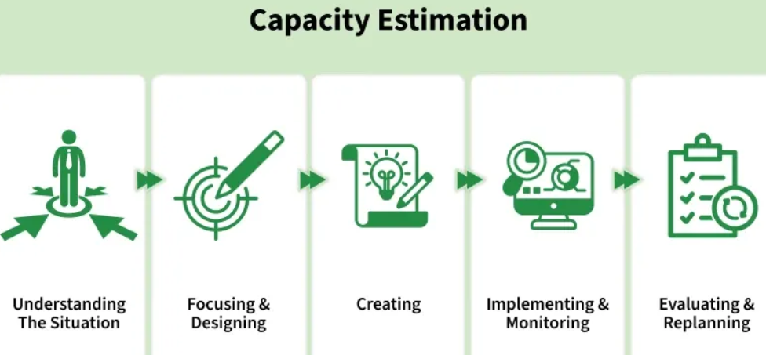
Factors that affect Capacity Estimation
Capacity estimation in system design depends on various factors, including:
- Hardware Resources: The capacity of a system depends on hardware components such as processors, memory, storage, and network interfaces. Better hardware resources generally increase system capacity.
- Software Efficiency: Efficient algorithms, optimized code, and well-designed software help make better use of hardware resources and improve overall system performance.
- Workload Characteristics: The nature, volume, and variability of workloads determine how much capacity the system requires to operate effectively.
- User Behavior: User activity patterns, transaction frequency, and concurrent access levels directly affect the system's capacity requirements.
- Scalability: The ability to add resources vertically or horizontally help the system handle growing workloads and improve capacity.
- Performance Metrics: Metrics such as response time, throughput, and resource utilization are used to measure and estimate system capacity.
- Failure Scenarios: Considering hardware failures, network outages, and other disruptions helps ensure sufficient capacity for reliability and fault tolerance.
Metrics for Capacity Estimation
In system design, several metrics are crucial for capacity estimation:
- Daily Active Users (DAU): This metric represents the number of unique users who access the application each day. It helps estimate the overall daily traffic the system must support.
- Queries Per Second (QPS): QPS measures the number of requests processed by the system every second. It indicates the load on servers and helps determine processing capacity.
- Storage Requirements: This metric defines the amount of data the system needs to store over time. It helps plan database and storage infrastructure capacity.
- Error Rates: Error rate measures the percentage of requests that fail or produce errors. It is an important indicator of system reliability and stability.
- Response Time: Response time is the duration the system takes to process a request and return a result. Lower response times generally indicate better performance.
- Concurrency: Concurrency refers to the number of users or requests the system can handle simultaneously without performance degradation.
- Peak Load Handling: This metric measures the maximum traffic or workload the system can support during peak usage periods while maintaining acceptable performance.
Methods and Techniques for Capacity Estimation
Capacity estimation in system design involves various methods and techniques to accurately predict the system's ability to handle workload. Here are some commonly used approaches:
- Traffic Analysis: This method studies user activity patterns, request volumes, and usage trends to estimate the load a system must handle.
- Forecasting: Forecasting uses historical data to predict future traffic growth and capacity requirements, helping organizations prepare for increased demand.
- Stress Testing: Stress testing intentionally pushes the system beyond normal limits to identify its breaking point and uncover performance bottlenecks.
- Historical Data Analysis: This approach analyzes past usage patterns and peak traffic periods to estimate future capacity needs more accurately.
- Load Testing: Load testing gradually increases workload levels to measure system performance and determine its capacity limits.
- Capacity Planning Tools: Specialized tools monitor resource utilization, performance metrics, and scalability trends to support accurate capacity estimation and planning.
Capacity Estimation for Different Components
Capacity estimation for different components in system design involves assessing the resources required by individual elements to ensure overall system performance. Here's an overview:
1. CPU (Central Processing Unit)
- Estimate CPU capacity based on factors such as processing power, clock speed, and the number of cores.
- Calculate CPU utilization under different workload scenarios to determine if additional processing capacity is needed.
2. Memory (RAM)
- Assess memory requirements by analyzing the system's memory usage patterns.
- Estimate peak memory usage and ensure sufficient RAM to accommodate simultaneous tasks and prevent performance degradation due to swapping or paging.
3. Storage
- Estimate storage capacity based on data growth rates, anticipated file sizes, and storage types (e.g., SSD, HDD).
- Consider factors like redundancy, data replication, and backup requirements when estimating storage capacity.
4. Network Bandwidth
- Evaluate network bandwidth requirements by analyzing expected data transfer rates, network traffic patterns, and communication protocols.
- Consider factors like peak usage periods, data compression, and network latency in capacity estimation.
5. Database Resources
- Estimate database capacity requirements based on factors such as data volume, transaction rates, and query complexity.
- Analyze database performance metrics like throughput, response time, and concurrency to determine if scaling or optimization is necessary.
Case Studies and Examples
1. E-commerce website
Let's you are building an online store and need to estimate capacity for a Black Friday sale. Here's how you would proceed:
Define Key Metrics
Estimate 200,000 DAU and Each user make 8 requests per visit, leading to a total of 1,600,000 requests.
- QPS= 1,600,000/86,400 = 18.52
- Storage requirements: If each user generates 5 MB of data, the total daily storage requirement is 200,000×5MB=1,000,000MB=1,000GB
- Concurrent users: 25% of DAU will be active at the same time, so: 200,000×0.25=50,000 concurrent users
- Conduct Load Testing: Use Apache JMeter to simulate 50,000 users and monitor the system's response time and error rates.
- Perform Stress Testing: Test the system with 250,000 users to identify any potential bottlenecks.
- Capacity Planning: Based on test results, scale the infrastructure by adding more servers or optimizing resources like caching.
- Post-Deployment Monitoring: Once live, monitor key metrics like DAU, QPS, and error rates using tools like Grafana.
2. Cloud Infrastructure Capacity Planning:
- Scenario: A company migrates its on-premises infrastructure to the cloud and needs to estimate the capacity requirements for various cloud resources.
- Capacity Estimation: The company analyzes historical usage data to identify resource utilization patterns and predicts future growth trends.
- Example Metrics: They estimate that their cloud environment requires 100 virtual machines, 10 TB of storage, and 1 Gbps of network bandwidth to support anticipated workloads.
- Optimization Strategy: The company implements auto-scaling policies to dynamically adjust resource allocation based on demand fluctuations, optimizing cost and performance.
- Outcome: By accurately estimating capacity requirements and implementing efficient resource management strategies, the company achieves cost-effective scalability and maintains high system availability in the cloud.
Challenges and Considerations
Capacity estimation in system design comes with several challenges and considerations that need to be addressed to ensure accurate predictions and optimal system performance.
- Dynamic Workloads: Workloads can change due to seasonal trends, promotions, or unexpected events, making accurate capacity estimation more difficult.
- Uncertain Growth Patterns: Future growth in users, data, and transactions is difficult to predict, requiring planners to prepare for multiple scalability scenarios.
- Hardware Limitations: CPU, memory, storage, and network constraints can restrict system growth and must be considered during capacity planning.
- Software Complexity: Modern systems contain many interconnected components, making it challenging to estimate capacity requirements and dependencies accurately.
- User Behavior Variability: Changes in user activity, peak usage periods, and transaction volumes can affect capacity needs and require continuous monitoring and analysis.
Best Practices for Capacity Estimation
Below are some of the best practices while doing capacity estimation:
- Start Early: Begin capacity estimation during the initial stages of system design to identify potential bottlenecks and scalability challenges.
- Gather Accurate Data: Collect and analyze accurate data on system usage, performance metrics, and workload patterns to inform capacity estimation.
- Consider Workload Variability: Account for variations in workload patterns, such as peak usage times and seasonal trends, when estimating capacity requirements.
- Plan for Scalability: Design systems with scalability in mind, utilizing techniques like horizontal and vertical scaling to accommodate future growth.
Tools and Resources for Capacity Estimation
- LoadRunner: LoadRunner is a performance testing tool that simulates real user activity to evaluate how an application performs under different workloads. It helps identify bottlenecks, slow response times, and resource limitations.
- Grafana: Grafana is a monitoring and visualization tool that displays real-time system metrics through interactive dashboards. It helps track performance, resource usage, and system health.
- Load Testing Tools: Tools such as Apache JMeter, LoadRunner, and Gatling are used to simulate user traffic and measure system performance under varying load conditions.
- Monitoring Platforms: Platforms like Prometheus, Nagios, and Datadog provide real-time monitoring of system metrics, resource utilization, and capacity trends to support effective capacity planning.
Client-Server Architecture - System Design
Client–server architecture is a system design model where multiple clients request services or resources from a centralized server. The server manages data, processing, and resources, while clients provide the user interface and interact with the server.
- Clients send requests to the server using protocols such as HTTP/HTTPS or SQL, and the server processes these requests and returns responses.
- The server handles data storage and processing centrally, while supporting vertical and horizontal scaling to accommodate growing workloads.
Example: When a user opens a website, the web browser (client) sends a request to the web server.The server processes the request, retrieves the required data, and sends the webpage back to the client for display.
Real-World Examples
Some are some real-world examples of Client Server Architecture are:
Banking Systems
Online banking applications use client-server architecture to provide secure access to banking services.
- Clients allow users to check account balances and perform transactions.
- Servers process requests and securely manage customer account data.
Enterprise Applications
Organizations use client-server architecture to manage business operations through centralized systems.
- Employees access ERP, CRM, and document management systems as clients.
- Servers store, process, and maintain organizational data centrally.
Telecommunications
Telecommunication services rely on client-server architecture for communication and media delivery.
- Client devices initiate calls, messaging, and video conferencing sessions.
- Servers handle call routing, signaling, and media streaming.
Internet of Things (IoT)
IoT systems use client-server architecture to collect, process, and analyze device data.
- IoT devices act as clients that send sensor data to servers.
- Servers process, store, and analyze data for monitoring and automation.
Healthcare Systems
Healthcare platforms use client-server architecture to manage medical information securely.
- Clients enable healthcare providers and patients to access services.
- Servers store patient records and support telemedicine applications.
Components of Client-Server Architecture
The following components work together to enable communication, processing, and service delivery in a client-server system.
- Client: A device or application that sends requests to the server and displays the received results to users.
- Server: A central system that processes client requests, manages resources, and returns appropriate responses.
- Network: Provides the communication channel between clients and servers, enabling reliable data transfer.
- Middleware: Acts as a bridge between components by handling services such as authentication, messaging, and logging.
- Database: Stores, organizes, and manages application data while ensuring security and consistency.
- User Interface (UI): The front-end component through which users interact with the application and view results.
- Application Logic: Contains the business rules and processing logic that handle requests and coordinate data flow between components.
Importance in System Design
Client-server architecture is critically important in system design for several reasons:
- Centralized Management: Simplifies maintenance, monitoring, and security by managing resources from a single server.
- Scalability: Supports growth by adding or upgrading servers without major changes to the system.
- Resource Optimization: Efficiently distributes workload between clients (interaction) and servers (processing & storage).
- Reliability and Availability: Ensures continuous service using redundancy, backups, and load balancing.
- Enhanced Security: Improves data protection through centralized control, encryption, and authentication.
Design Principles for Effective Client-Server Architecture
Designing an effective client-server architecture involves several key principles that ensure the system is robust, scalable, secure, and efficient. Here are the main design principles:
1. Modularity
Modularity divides the system into independent components, making development and maintenance easier.
- Separation of Concerns: Split the system into client, server, and database modules with specific responsibilities.
- Reusability: Design components that can be reused across different systems or projects.
2. Scalability
Scalability enables the system to handle increasing workloads efficiently.
- Horizontal Scalability: Increase capacity by adding more servers or instances.
- Vertical Scalability: Improve performance by upgrading CPU, memory, or storage resources.
3. Reliability and Availability
Reliability ensures continuous system operation even during failures or high traffic.
- Redundancy: Use multiple servers to avoid service interruption during failures.
- Load Balancing: Distribute requests across servers to prevent bottlenecks and improve availability.
4. Performance Optimization
Performance optimization improves system speed and resource efficiency.
- Efficient Communication: Reduce latency and bandwidth usage through optimized protocols.
- Caching: Store frequently accessed data closer to clients for faster response times.
5. Security
Security protects system resources and data from unauthorized access.
- Authentication and Authorization: Allow access only to verified users and authorized clients.
- Encryption: Secure data transmission using protocols such as SSL/TLS.
Steps for Client-Side Design and Server-Side Design
Designing a client-server architecture involves distinct steps for both the client-side and server-side development. Here are the steps for each:
1. Client-Side Design
Client-side design focuses on how the user interface is built and how it interacts with the server to request and display data.
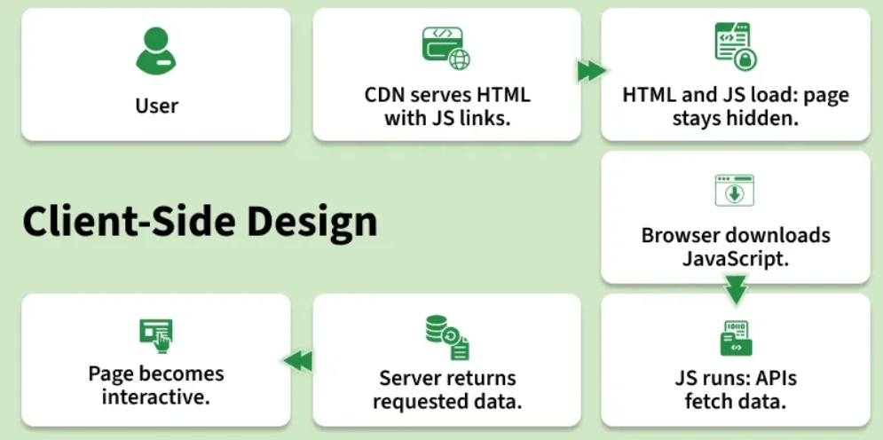
- User Requests a Website: The process begins when a user requests a website by entering a URL in the browser or clicking a link.
- CDN Serves HTML Files: A Content Delivery Network (CDN) quickly serves the HTML files, which contain links to the JavaScript files needed for the website.
- Browser Downloads HTML and JavaScript: The browser first downloads the HTML file and then proceeds to download the linked JavaScript files. During this phase, the site may not be fully visible to the user, as it waits for the JavaScript to render the content.
- Browser Downloads the JavaScripts: The browser continues to download the JavaScript files specified in the HTML.
- JavaScript Execution and API Calls: Once downloaded, the JavaScript is executed. During execution, the JavaScript makes API calls to the server to fetch the necessary data. At this stage, placeholders may be visible to the user while the actual data is being fetched.
- Server Responds with Data: The server responds to the API requests with the required data. This data is sent back to the client-side application.
- Data Fills Placeholders: The data fetched from the APIs fills the placeholders in the client interface. The page becomes fully interactive and visible to the user.
2. Server-Side Design
Server-side design focuses on processing client requests, handling business logic, and managing data storage and responses.
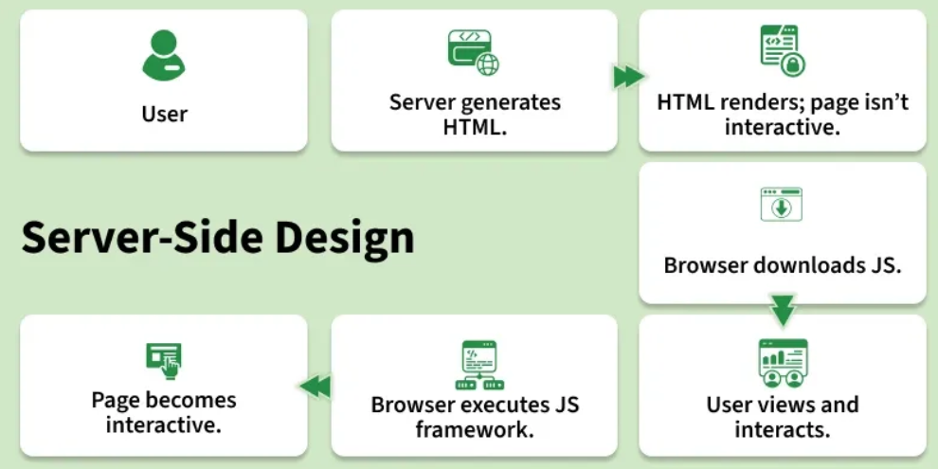
- User Requests a website: The process starts when a user requests a website.
- Server Creates "Ready to Render" HTML Files: The server processes the request and generates HTML files that are ready to be rendered.
- The Browser Can Quickly Render the HTML, but the Site Isn't Interactive: The browser receives and renders the HTML quickly, allowing the user to see the content immediately, but the site is not yet interactive.
- The Browser Downloads the JavaScript: The browser then downloads the necessary JavaScript files.
- The User Can View Content and the Interactions Can Be Recorded: The user can view the content while the JavaScript is being downloaded. User interactions can be recorded even though the site is not fully interactive yet.
- The Browser Executes the JS Framework: Once the JavaScript is downloaded, the browser executes the JavaScript framework (e.g., React, Angular).
- The Recorded Interactions Can Be Executed and the Page Is Now Interactive: The recorded interactions are executed, and the page becomes fully interactive.
Types of Network Protocols
Network protocol is a collection of rules that governs how data is transmitted, received, and interpreted between devices on a network, regardless of their internal structure or design.
- Defines what, how, and when data is communicated.
- Enables communication between heterogeneous devices.
- Ensures reliable and standardized data exchange.
- Prevents data loss, duplication, and misinterpretation.
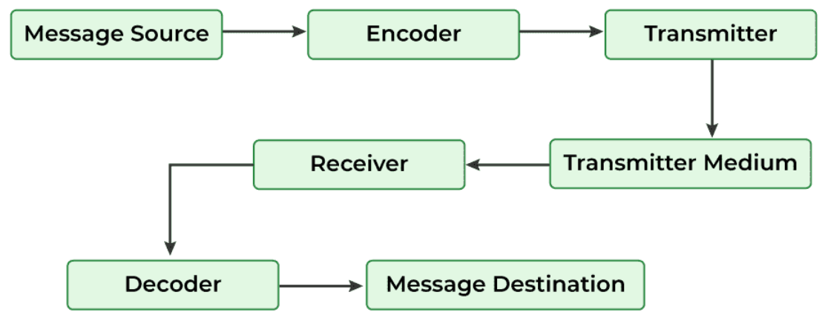
What is a Network Protocol?
A network protocol is a set of rules and standards that define how devices communicate over a network. These rules govern how data is formatted, transmitted, received, processed, and acknowledged between systems.
Examples of network protocols include HTTP, HTTPS, TCP, UDP, IP, DHCP, FTP, and DNS.

OSI Model (Open Systems Interconnection)
Network communication is commonly explained using the OSI Model, which divides communication into 7 layers. Each layer performs a specific function and communicates with the corresponding layer on the receiving device.
7 Layers of the OSI Model
Layer Number | Layer Name | Function | Examples
7 | Application Layer | Provides network services to end-user applications | HTTP, HTTPS, FTP, SMTP, DNS
6 | Presentation Layer | Data translation, encryption, compression | SSL/TLS, JPEG, ASCII
5 | Session Layer | Establishes, manages, and terminates sessions | NetBIOS, RPC
4 | Transport Layer | Reliable or fast end-to-end data delivery | TCP, UDP
3 | Network Layer | Logical addressing and routing | IP, ICMP, BGP
2 | Data Link Layer | Physical addressing and error detection | Ethernet, ARP, PPP
1 | Physical Layer | Transmission of raw bits over physical media | Cables, Fiber, Wireless Signals

The 7 Layers of the OSI Model
Layer 7: Application Layer
Provides network services directly to end-user applications.
Examples: HTTP, HTTPS, FTP, SMTP, DNS
Layer 6: Presentation Layer
Handles data translation, encryption, and compression.
Functions:
- Data formatting
- Encryption/Decryption
- Compression/Decompression
Examples: TLS, SSL, JPEG, ASCII
Layer 5: Session Layer
Establishes, manages, and terminates communication sessions between applications.
Functions:
- Session management
- Synchronization
- Session recovery
Layer 4: Transport Layer
Provides end-to-end communication between devices.
Functions:
- Segmentation
- Flow control
- Error detection
- Reliable delivery
Examples: TCP, UDP
Layer 3: Network Layer
Responsible for logical addressing and routing.
Functions:
- Packet forwarding
- Routing
- Path determination
Examples: IP, ICMP, BGP
Layer 2: Data Link Layer
Provides node-to-node communication and physical addressing.
Functions:
- MAC addressing
- Error detection
- Frame transmission
Examples: Ethernet, ARP, PPP
Layer 1: Physical Layer
Transmits raw bits over the communication medium.
Examples:
- Fiber optic cables
- Ethernet cables
- Wireless signals

OSI Layer Mnemonic
All People Seem To Need Data Processing
(Application → Presentation → Session → Transport → Network → Data Link → Physical)

How Network Protocols Work
- Communication is commonly explained using the OSI model, although the Internet primarily uses the TCP/IP model.
- Each layer performs a specific function and uses dedicated protocols.
- Data moves down the layers at the sender's side and up the layers at the receiver's side.
- Each layer adds its own information (headers) to the data before transmission.
- Internet Protocol (IP) operates at the Network Layer and handles addressing and routing.
- Layered communication improves reliability, scalability, interoperability, and troubleshooting.

Types of Network Protocols
Network protocols are broadly classified into three major categories:
- Network Communication Protocols
- Network Management Protocols
- Network Security Protocols

1. Network Communication Protocols
These protocols enable communication and data exchange between devices and applications.

HTTP (Hypertext Transfer Protocol)
HTTP is an application-layer protocol used for transferring web pages and data across the World Wide Web.
Features
- Client-server architecture
- Used for loading web pages
- Stateless protocol
- Default Port: 80
- Data is transmitted in plain text

HTTPS (Hypertext Transfer Protocol Secure)
HTTPS is the secure version of HTTP that uses TLS encryption.
Features
- Encrypts data transmission
- Protects against interception and tampering
- Ensures confidentiality and integrity
- Default Port: 443
- Identified by a lock icon in web browsers

TCP (Transmission Control Protocol)
TCP is a connection-oriented transport-layer protocol that provides reliable communication.
Features
- Reliable data delivery
- Error detection and correction
- Flow control
- Ordered packet delivery
- Retransmission of lost packets
Three-Way Handshake
- SYN
- SYN-ACK
- ACK
Common Uses
- HTTPS
- FTP
- Email services

UDP (User Datagram Protocol)
UDP is a connectionless protocol designed for high-speed data transmission.
Features
- No connection establishment
- Minimal overhead
- Low latency
- No retransmission
- No delivery guarantee
Common Uses
- Live streaming
- Online gaming
- DNS queries
- VoIP calls

Internet Protocol (IP)
IP is responsible for addressing and routing packets across networks.
Features
- Provides logical addressing
- Routes packets between networks
- Connectionless protocol
- Best-effort delivery
Versions
IPv4 Example: 192.168.1.10
IPv6 Example: 2001:db8::1

Address Resolution Protocol (ARP)
ARP maps IPv4 addresses to MAC addresses within a local network.
Features
- Converts IP addresses to MAC addresses
- Maintains an ARP cache
- Uses ARP Request and ARP Reply messages
- Essential for communication within LANs
- Applicable to IPv4 networks

Dynamic Host Configuration Protocol (DHCP)
DHCP automatically assigns network configuration information to devices.
Information Provided by DHCP
- IP Address
- Subnet Mask
- Default Gateway
- DNS Server
DHCP Process (DORA)
- Discover
- Offer
- Request
- Acknowledge
Benefits
- Eliminates manual IP configuration
- Reduces IP conflicts
- Simplifies network administration

Border Gateway Protocol (BGP)
BGP is the routing protocol used to exchange routing information between Autonomous Systems (AS) on the Internet.
Features
- Inter-AS routing
- Policy-based routing
- Loop prevention
- Highly scalable
- Backbone protocol of the Internet

2. Network Management Protocols
These protocols help monitor, manage, and troubleshoot network operations.

Internet Control Message Protocol (ICMP)
ICMP is used for diagnostics and error reporting.
Features
- Reports unreachable destinations
- Detects packet delivery issues
- Supports ping and traceroute
- Helps troubleshoot network problems
Common Messages
- Echo Request
- Echo Reply
- Destination Unreachable
- Time Exceeded

Simple Network Management Protocol (SNMP)
SNMP is used to monitor and manage network devices.
Components
- SNMP Manager
- SNMP Agent
- Managed Devices
Uses
- Monitor network health
- Track bandwidth usage
- Detect faults
- Monitor CPU and memory usage

File Transfer Protocol (FTP)
FTP enables file transfer between local and remote systems.
Features
- Uploading files
- Downloading files
- User authentication
- Built on TCP
Ports
- Port 21 (Control)
- Port 20 (Data)
Limitation
FTP transfers data in plain text.
Secure Alternatives
- FTPS
- SFTP

Post Office Protocol Version 3 (POP3)
POP3 retrieves emails from a mail server to a local device.
Features
- Downloads emails locally
- Usually removes emails from the server
- Suitable for single-device use
- Simple and lightweight
Ports
- Port 110
- Port 995 (Secure POP3)

Telnet
Telnet allows remote access to a system through a command-line interface.
Features
- Remote login
- Command execution
- Client-server architecture
Port
- Port 23
Limitation
Data is transmitted in plain text.
Modern Alternative
SSH (Secure Shell)

Gopher
Gopher is an early protocol used for file searching and retrieval.
Features
- Hierarchical structure
- Menu-driven navigation
- File retrieval from remote systems
Current Status
Largely obsolete and replaced by HTTP and the World Wide Web.

3. Network Security Protocols
These protocols secure communication by providing encryption, authentication, and data integrity.

Secure Sockets Layer (SSL)
SSL was developed to secure communication over networks.
Features
- Encrypts transmitted data
- Protects sensitive information
- Supports secure communication
Note
SSL is deprecated and has been replaced by TLS. However, the term "SSL" is still commonly used.

Transport Layer Security (TLS)
TLS is the modern standard for secure communication.
Features
- Encryption
- Authentication
- Data integrity verification
- Protection against tampering
Common Uses
- HTTPS
- Secure Email
- VPNs
- VoIP

Point-to-Point Tunneling Protocol (PPTP)
PPTP is a VPN protocol used for creating secure tunnels over public networks.
Features
- Supports remote access VPNs
- Easy to configure
- Encapsulates PPP traffic
Limitation
PPTP is considered insecure today and has largely been replaced by:
- IPsec
- OpenVPN
- Wire Guard

Other Important Network Protocols
Internet Message Access Protocol (IMAP)
IMAP allows users to access and manage emails directly from the server.
Features
- Emails remain stored on the server
- Multi-device synchronization
- Folder management
- Better suited for modern email usage than POP3

Session Initiation Protocol (SIP)
SIP is used to establish, manage, and terminate communication sessions.
Features
- Voice calls
- Video calls
- Messaging sessions
- VoIP communication

Real-Time Transport Protocol (RTP)
RTP supports the real-time transmission of audio and video data.
Features
- Real-time communication
- Sequence numbering
- Timestamping
- Used in video conferencing and live streaming

Trivial File Transfer Protocol (TFTP)
TFTP is a lightweight file transfer protocol.
Features
- Uses UDP
- No authentication
- Minimal overhead
- Commonly used for firmware updates and network booting

TCP vs UDP Comparison
TCP
- Connection-oriented
- Reliable
- Error recovery available
- Ordered delivery
- Slower due to additional overhead
UDP
- Connectionless
- Faster
- No retransmission
- No delivery guarantee
- Suitable for real-time applications
Proxies in System Design
A proxy server acts as an intermediary between a client and a server, forwarding requests and responses between them. It helps manage and control traffic while improving performance, security, and privacy.
- Forwards client requests to servers and returns responses while hiding client identity to enhance security.
- Improves performance through caching and efficient traffic control mechanisms.
Example: When a user accesses a website through a proxy server, the request first goes to the proxy, which forwards it to the website. The website responds to the proxy, which then sends the data back to the user.
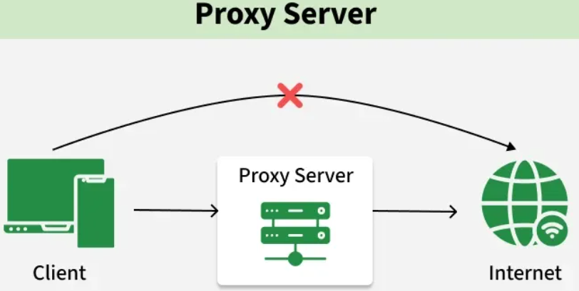
Purpose
Proxy servers are used to improve security, performance, and control over network traffic.
- Content Filtering: Proxies can block access to specific websites or content categories based on policies, helping enforce usage rules and prevent access to harmful content.
- Privacy & Anonymity: Forward proxies hide the client’s IP address, providing anonymity and protecting user identity and location.
- Security & Access Control: Proxies inspect incoming traffic, block malicious content, and enforce access control to protect sensitive resources.
- Load Balancing: Reverse proxies distribute incoming requests across multiple servers, improving performance and preventing server overload.
- Caching: Proxies store frequently accessed data locally, reducing server load and improving response time.
Types of Proxies
Proxy servers can be broadly categorized based on whether they act on behalf of the client or the server.
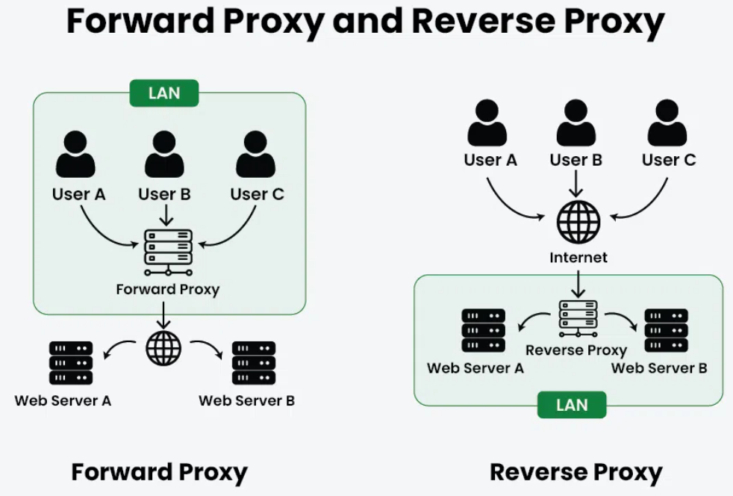
1. Forward Proxy
A server that serves as an intermediary between your computer or other device and the internet is known as a forward proxy. Your request passes through the forward proxy before reaching the website when you attempt to view it. On your behalf, the proxy then submits the request to the website, receives the response, and sends it back to you.
Example: Used in corporate networks to restrict employee internet access
When to use
- IP Masking: To hide the client’s IP address from the server
- Traffic Management: Handles requests from multiple clients through a single proxy
- Content Filtering: Blocks access to specific websites or content
2. Reverse Proxy
A reverse proxy is a server that sits between clients (like web browsers) and another server, handling requests on behalf of that server. Instead of a client connecting directly to the main server, the reverse proxy intercepts requests and forwards them to the server.
Example: Used by companies like Netflix or Amazon to handle millions of user requests via load balancing
When to use
- Load balancing: Distributes traffic across multiple servers.
- Security: Helps reduce DDoS attacks by hiding backend servers.
- Caching: Stores server responses to improve performance.
Common Proxy Tools
Various tools are used to implement proxy servers based on different use cases like caching, load balancing, and security.
- Nginx: Acts as a reverse proxy and load balancer
- HAProxy: High-performance load balancing proxy
- Squid: Forward proxy mainly used for caching and filtering
- Varnish: HTTP caching proxy used to speed up web applications
Use in System Design
Proxy servers are widely used in modern architectures to improve performance, security, and scalability.
- Used in API Gateways to route and manage requests (reverse proxy behavior)
- Used in CDNs to deliver content from edge servers
- Used in Microservices Architecture for routing, security, and communication
- Used in Enterprise Networks for monitoring, filtering, and access control
Proxy Server Implementation Strategy
Proxy server implementation involves designing and configuring proxies to improve performance, security, and scalability of a system.
- Reverse Proxy vs Forward Proxy: Reverse proxies handle requests on behalf of servers (used for load balancing, security), while forward proxies act on behalf of clients (used for anonymity, access control).
- Proxy Server Software: Choose suitable tools like Nginx, Apache, HAProxy, Squid, or Varnish based on performance, scalability, and compatibility with your system.
- Deployment Architecture: Decide between centralized (single proxy) or distributed (multiple proxies) architecture for better performance and fault tolerance.
- Load Balancing: Distribute incoming traffic across multiple servers to avoid overload and ensure high availability.
- Authentication & Authorization: Implement access control using methods like Basic Auth, LDAP, or token-based authentication to restrict usage.
- Security Measures: Use SSL/TLS encryption, firewalls, and ACLs to protect against unauthorized access and attacks.
- Caching & Content Filtering: Cache frequently accessed data to reduce latency and filter unwanted or harmful content based on policies.
- Logging & Monitoring: Track requests, errors, and performance metrics to ensure system health and troubleshoot issues.
- Scalability & High Availability: Use clustering, replication, and failover techniques to handle increased traffic and avoid downtime.
Advantages
The advantages of proxy servers are as follow:
- Enhanced Security: Proxies act as a barrier between client and the internet, filtering out malicious content and imparting an extra layer of defense towards cyber threats.
- Improved Performance: Caching mechanisms in proxies boost up content delivery by means of storing regularly accessed data locally, reducing the need to fetch resources from the origin server.
- Load Balancing: Reverse proxies distribute incoming visitors across a couple of servers, optimizing resource usage, and ensure high availability.
Disadvantages
The disadvantages of proxy servers are as follow:
- Latency: Introducing a proxy can add latency to the communication between user and servers, impacting the reaction time, in particular for real-time application.
- Configuration Complexity: Setting up and handling proxy servers may be complicated, requiring knowledge of networking and security to make certain proper configuration and to increase overall performance.
Forward Proxy Vs Reverse Proxy
These two types of proxies differ based on whether they act on behalf of the client or the server and how they handle request flow.
Forward Proxy | Reverse Proxy
Acts on behalf of the client | Acts on behalf of the server
Client is aware and configures it | Client is usually unaware
Used for anonymity, access control, and filtering | Used for load balancing, security, and performance
Caches internet data to improve client access speed | Caches server responses to reduce backend load

Draw High Level Design Diagram
A High-Level Design (HLD) diagram provides a visual overview of a system's architecture, showing the major components and how they interact. It focuses on the overall structure rather than implementation details.
- Shows the major system components and the flow of data between them.
- Illustrates how the system integrates with external services and its overall environment.
Example of High-Level Design Diagram of an Online Food Delivery System
A High-Level Design (HLD) of an Online Food Delivery System shows the major components of the system and how they communicate with each other. It provides an architectural overview without focusing on implementation-level details.
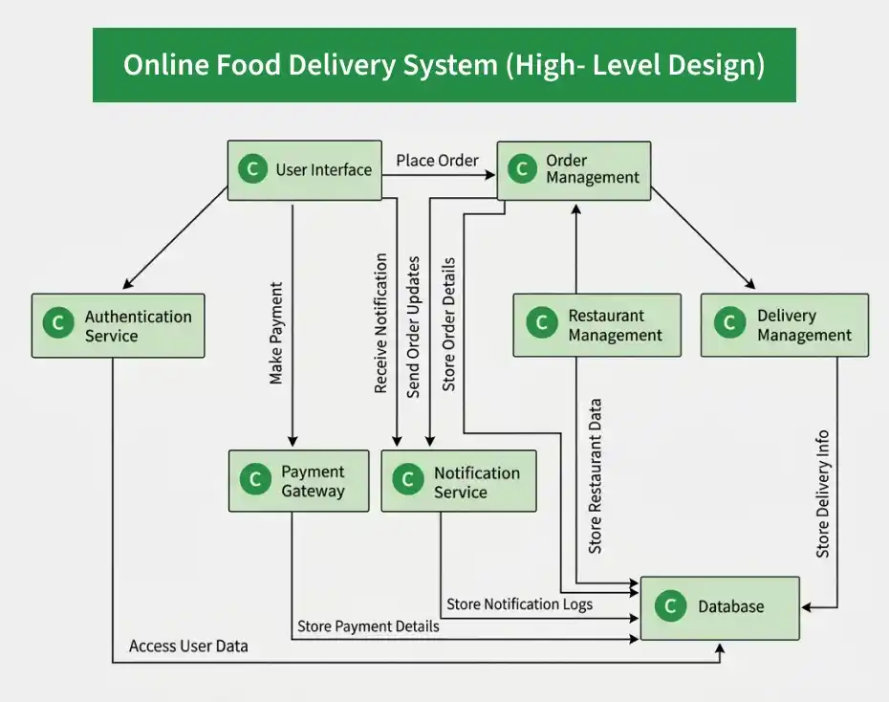
In above example, the HLD includes the main elements commonly found in high-level system design:
- User Interface: Allows users to browse restaurants and menus, place orders, make payments, and track deliveries.
- Modules/Subsystems: Services such as Authentication, Order Management, Restaurant Management, Notification, and Delivery Management handle specific system functions.
- Interfaces/APIs: Enable communication between the user interface, application services, external systems, and data storage.
- Data Flow: Shows how requests and information, such as orders, payments, and delivery updates, move between components.
- Data Storage: Stores user information, restaurant data, orders, payment records, and other application data.
- External Systems: Services such as payment gateways, maps/location APIs, and SMS or email providers integrate with the application.
- Deployment/Infrastructure: Components such as load balancers, servers, containers, and cloud services provide the infrastructure required to run and scale the system.
Importance
High-Level Design (HLD) diagrams provide a clear overview of the system architecture, making it easier to design, communicate, and manage complex systems.
- Improve communication by helping stakeholders and developers understand the overall system architecture.
- Support project planning by simplifying resource allocation, task distribution, and implementation planning.
- Make complex systems easier to understand by showing how major components interact.
- Serve as valuable documentation and help identify potential design issues early in the development process.
Preparation Required Before Drawing a High-Level Design Diagram
First of all, a number of preparatory steps have to be taken before drawing an HLD diagram in order to avoid mistakes and omissions and produce a truly helpful and informative diagram.
1. Requirements Analysis
Requirements analysis helps identify the overall requirements, scope, and constraints of the project.
- Gather Requirements: Collect business goals, functional requirements, non-functional requirements, and project constraints from stakeholders.
- Analyze Requirements: Review and categorize the collected requirements to understand the system's expected functionality.
- Prioritize Requirements: Rank requirements based on business importance and implementation priority.
- Document Requirements: Record all requirements clearly using requirement specifications or user stories.
2. Stakeholder Input
Stakeholder input helps ensure that the system design addresses the needs, expectations, and concerns of all relevant stakeholders.
- Identify Stakeholders: Identify all individuals, teams, or organizations that are affected by or involved in the system.
- Gather Stakeholder Input: Collect their requirements, expectations, concerns, and feedback through meetings, interviews, surveys, or workshops.
- Resolve Conflicts: Identify and resolve conflicting requirements or priorities between different stakeholders.
- Validate Requirements: Review the proposed requirements with stakeholders and ensure that they are accurate, complete, and aligned with business objectives.
- Obtain Approval: Get confirmation or approval from the relevant stakeholders before moving forward with the system design.
3. System Context
System context defines the environment in which the system operates. It helps identify the system boundaries, external entities, and interactions with other systems.
- Context Diagram: Show the system's interactions with users, external applications, and third-party services.
- Define Boundaries: Clearly specify what is inside and outside the system scope.
- External Interactions: Identify APIs, integrations, and data exchange points with external systems.
- Assumptions & Dependencies: Document key assumptions and dependencies that may impact the system design.
4. Technology Stack
Technology stack selection helps ensure that the system can meet its functional and non-functional requirements while considering scalability, security, maintainability, compatibility, cost, and project constraints.
- Research Technologies: Explore suitable programming languages, frameworks, databases, cloud services, and other technologies based on the system requirements.
- Evaluate Options: Compare different technologies based on performance, scalability, security, compatibility, maintainability, cost, and project constraints.
- Select Technologies: Choose the technologies that best fit the system requirements, technical constraints, and project goals.
- Document Decisions: Record the selected technology stack and the reasons, trade-offs, and constraints considered when making each technology decision.
5. Standards and Conventions
Following standard design practices ensures the HLD diagram is consistent, easy to understand, and maintainable.
- UML Standards: Use standard UML notations to create clear and consistent diagrams.
- Naming Conventions: Follow consistent naming rules for modules, components, and interfaces.
- Design Patterns: Apply proven design patterns where appropriate to improve system design.
- Documentation Standards: Maintain consistent documentation so the design is easy for the entire team to understand.
Tools for Creating High-Level Design Diagrams
The right diagramming tool helps create clear, professional, and easy-to-maintain HLD diagrams.
- Microsoft Visio: Microsoft Visio is a professional diagramming tool commonly used for enterprise system design. It supports UML, flowcharts, network diagrams, and other technical diagrams, and integrates with Microsoft Office tools.
- Lucidchart: Lucidchart is a cloud-based diagramming platform designed for real-time collaboration. It allows multiple users to create and edit diagrams simultaneously and integrates with tools like Google Drive, Slack, and Confluence.
- Draw.io (Diagrams.net): Draw.io is a free online diagramming tool suitable for creating system design diagrams. It offers a wide range of templates and diagramming shapes and integrates with cloud storage.
Techniques for Creating High-Level Design Diagrams
Below are some techniques for creating high-level design:
1. Unified Modeling Language (UML)
A standardized modeling language used to specify, visualize, construct, and document different aspects of software systems.
- Diagrams: Includes various types of diagrams such as class diagrams, sequence diagrams, use case diagrams, activity diagrams, and component diagrams, each using standardized notation to represent different aspects of a system.
- Use Case: Used to model and communicate the structure, behavior, interactions, and relationships within a software system in a standardized and widely understood way.
2. Block Diagrams
Diagrams that use blocks to represent system components and lines to show relationships between them.
- Components: Typically include blocks (modules) and connectors (interactions or data flows).
- Use Case: Useful for high-level representations that focus on the main components and their interactions.
3. Entity-Relationship Diagrams (ERD)
Entity-Relationship Diagrams (ERDs) are primarily used for database and data modeling, illustrating entities, attributes, and relationships between them. An ERD can support HLD by helping represent the system's data model, but it does not represent the complete high-level system architecture.
- Components: Includes entities (tables), attributes (columns), and relationships between entities.
- Use Case: Useful for designing and visualizing database schemas and understanding how data is structured within the system.
4. Flowcharts
Diagrams that represent the flow of processes or systems using symbols.
- Components: Includes start/end points, processes, decisions, and arrows indicating flow direction.
- Use Case: Suitable for visualizing specific process flows and decision-making logic within a system. Flowcharts complement HLD by representing process-level behavior rather than the complete system architecture.
5. Data Flow Diagrams (DFD)
Diagrams that depict the flow of data within a system.
- Components: Includes processes, data stores, data flows, and external entities.
- Use Case: Useful for understanding and documenting how data moves between processes, data stores, and external entities. DFDs complement HLD by focusing on data movement rather than the complete system architecture.
Step-by-Step Guide to Drawing High-Level Design Diagrams
Follow these steps to create a clear and well-structured High-Level Design (HLD) diagram.
- Identify Major Components: Determine the main modules or services of the system.
- Define Relationships: Specify how the components communicate and interact with each other.
- Create a Preliminary Layout: Sketch the overall architecture to visualize the system structure.
- Use a Diagramming Tool: Create the diagram using tools like Lucidchart, Visio, or Draw.io.
- Add Details: Include data flow, external systems, and key interactions between components.
- Review and Revise: Validate the diagram with stakeholders and update it based on feedback.
- Finalize the Diagram: Add labels, annotations, legends, and other finishing touches for clarity.
Common Mistakes to Avoid While Drawing High-Level Design Diagram
Below are some common mistakes while drawing high-level design diagram:
- Too Much Detail: Adding too much information to an HLD diagram can make it complex and difficult to understand. Focus on major components and their relationships, while keeping detailed logic in other design documents.
- Ignoring Stakeholders: Not involving stakeholders during the design phase can lead to misunderstandings and poor design decisions. Include architects, developers, and stakeholders during design reviews to ensure the system meets business and technical needs.
- Lack of Consistency: Using inconsistent symbols or notations can confuse people who read the diagram. Follow standard notations such as UML and maintain consistent labels, shapes, and structures.
- Neglecting Updates: System architecture may change as the project evolves. Regularly update the HLD diagram to reflect the latest design and keep the documentation accurate.
High-Level Design (HLD) Diagrams - Complete Notes
HLD diagrams show the overall architecture of a system, its major components, and how those components interact. They are used by architects, developers, testers, DevOps teams, and stakeholders to understand the system before implementation.
1. System Context Diagram
Purpose
Shows the system and all external entities interacting with it.
Example
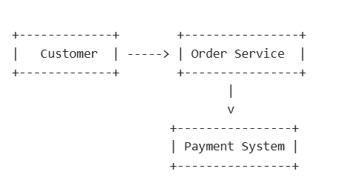
Used For
- Project kickoff
- Requirement discussions
- Understanding system boundaries
Shows
✅ Users
✅ External systems
✅ APIs
✅ Communication flow
❌ Internal implementation details
2. Component Diagram
Purpose
Shows major modules/components inside the application.
Example
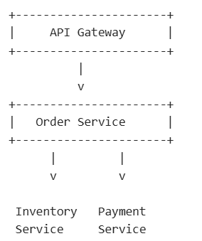
Used For
- Monolithic architecture
- Microservices architecture
- Internal service design
Shows
- Components
- Dependencies
- Relationships
3. Deployment Diagram
Purpose
Shows where applications are deployed physically or logically.
Example
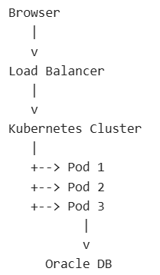
Used For
- Infrastructure design
- Cloud architecture
- Kubernetes deployment
Shows
- Servers
- Pods
- VMs
- Containers
- Databases
4. Sequence Diagram
Purpose
Shows how systems interact over time.
Example
User -> API Gateway
API Gateway -> Order Service
Order Service -> Inventory Service
Inventory Service --> Order Service
Order Service -> Payment Service
Payment Service --> Order Service
Order Service --> API Gateway
API Gateway --> User
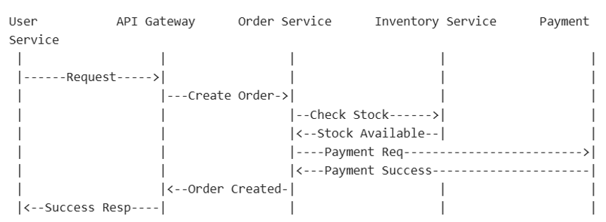
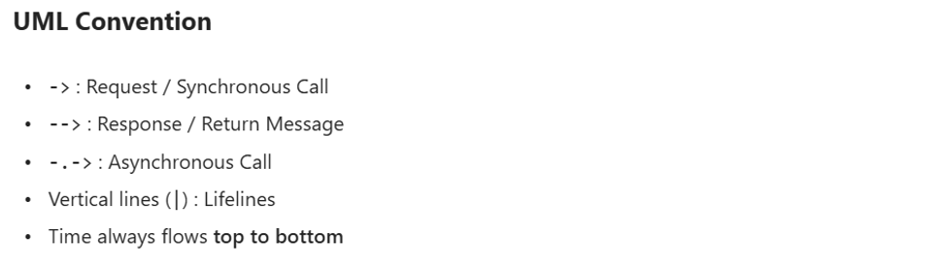
Used For
- API flow, Transaction flow and Request processing
Key Feature
Time progresses from top to bottom.
5. Data Flow Diagram (DFD)
Purpose
Shows data movement through the system.
Example
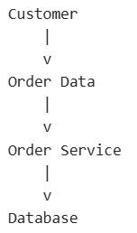
Focuses On
- Data creation
- Data transformation
- Data storage
6. Network Diagram
Purpose
Shows network connectivity.
Example
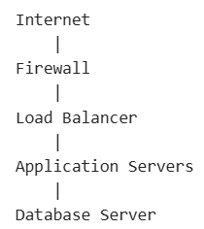
Used For
- Security architecture
- Infrastructure planning
7. Service Interaction Diagram
Purpose
Shows communication among microservices.
Example
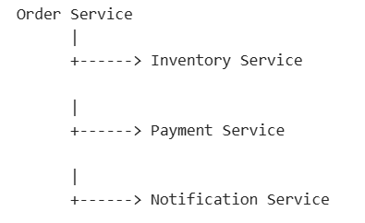
Used For
Microservice architecture documentation.
8. Database Diagram (ER Diagram)
Purpose
Shows entities and relationships.
Example
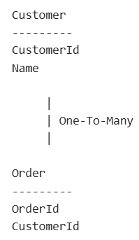
Used For
- Database design
- Schema discussions
9. Event Flow Diagram
Used in Event-Driven Architectures.
Example
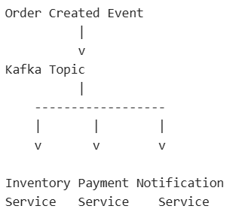
10. Container Diagram (C4 Model)
Purpose
Shows containers within a system.
Container means:
- Application
- Database
- Microservice
- Web App
Example
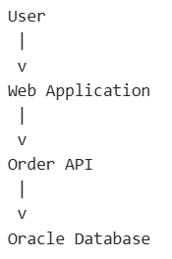
Common Notations Used In HLD
1. Arrow (→)
Meaning
Represents communication, flow, request, dependency, or relationship.
Example

2. Double Arrow (↔)
Meaning
Bidirectional communication.
Example

Meaning:
Both services can communicate with each other.
3. Dotted Arrow (----->)
Meaning
Dependency or asynchronous communication.
Example
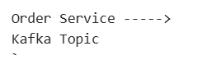
Meaning:
Order Service publishes event to Kafka.
UML Meaning
Dotted arrows often represent:
- Dependency
- Event publishing
- Async invocation
4. Solid Line
Meaning
Direct association between components.

5. Dotted Line
Meaning
Weak dependency.

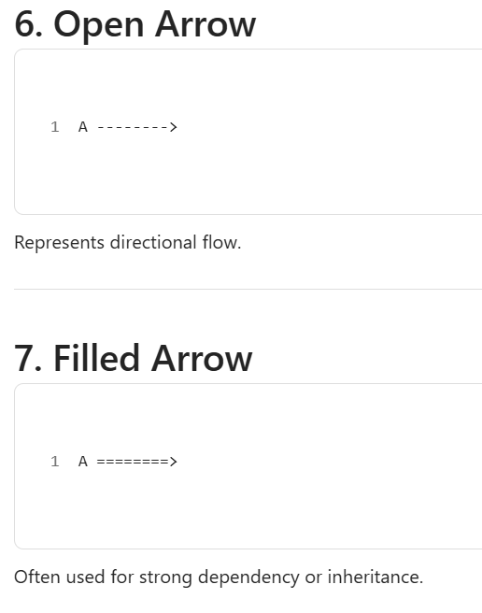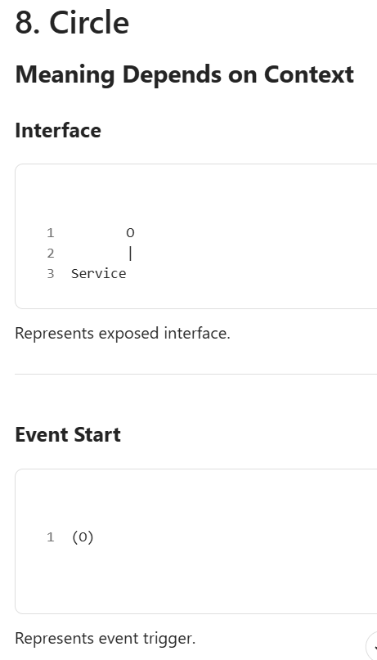
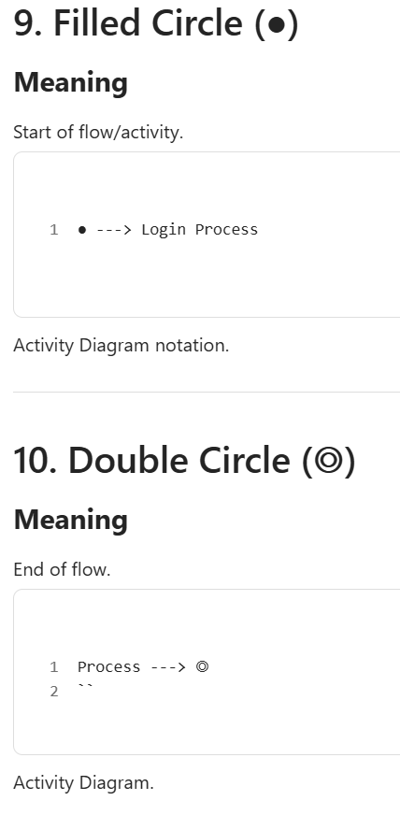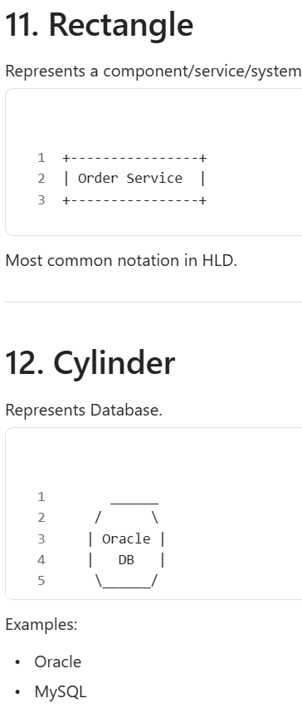
Choosing the Right Scalability Approach
Choosing the right scalability approach depends on your system’s traffic, workload, budget, and future growth. It helps ensure performance, reliability, and efficient resource usage.
- Vertical scaling: Suitable for simple applications with limited growth needs.
- Horizontal scaling: Best for high traffic, distributed systems, and long-term scalability.
Example: A small blog website with limited users may scale vertically by upgrading the server’s CPU and RAM. In contrast, a large e-commerce platform with millions of users may use horizontal scaling by adding multiple servers behind a load balancer to handle high traffic.
Factors That Affect Choosing the Correct Scalability Method
The appropriate scaling approach depends on several factors:
- Application Architecture: A monolithic application may be simpler to scale vertically, while independently deployable services can make horizontal scaling of individual components easier. The choice depends on the system design.
- Database Requirements: Consider the data model, consistency, query patterns, transactions, workload, and scalability needs. Both SQL and NoSQL databases can support large-scale systems.
- Cost: Costs depend on infrastructure pricing, resource utilization, workload, licensing, and operational complexity. Neither approach is always more cost-effective.
- Availability and Fault Tolerance: Horizontal scaling can improve redundancy and fault tolerance by distributing workloads across multiple instances with load balancing and failure-handling mechanisms.
- Latency Requirements: Latency depends on network distance, caching, database performance, processing time, and data location. Horizontal scaling alone does not guarantee lower latency.
- Traffic Patterns: Applications with variable workloads may benefit from elastic or serverless scaling that adjusts resources based on demand, subject to system limits.
- Technology Stack: The technology stack and architecture influence which scaling approaches are practical. Tools such as Kubernetes can help manage horizontally scaled containerized workloads.
Making the Right Choice
So, when do you use which method? Here are some scenarios:
1. Small and Steady
Select vertical scaling if you are not expecting your application's user traffic and resource requirements growing quickly because:
- Increasing a single server's capacity by adding extra CPU, RAM, or storage to accommodate growing loads is known as vertical scaling.
- It is often simpler and requires fewer changes to your application architecture compared to horizontal scaling.
- Suitable for small-scale applications that don't need to handle a large number of concurrent users.
2. Going Big
If you expect a high increase in user traffic and need to ensure your application can handle it, go for Horizontal Scaling, especially if your app is divided into pieces (microservices) because:
- Horizontal scaling involves adding more servers or instances to your infrastructure, distributing the load across multiple machines.
- It offers better scalability as you can continue to add more servers as your user base grows.
- Particularly effective for applications that are designed as microservices, allowing you to scale each service independently.
3. Variable Loads
Serverless can be an excellent choice for applications with unpredictable traffic patterns or occasional spikes in activity because:
- Serverless computing is perfect for variable workloads since it automatically controls resource scalability depending on demand.
- You only pay for the actual resources used, which can be cost-effective when your application has idle periods.
- Serverless platforms, such as AWS Lambda or Azure Functions, handle the underlying infrastructure, reducing operational overhead.
4. Need for Speed
When your application needs to provide low-latency responses and high performance, horizontal scaling is the good option because:
- Horizontal scaling allows you to distribute traffic across multiple servers, reducing the load on each server and improving response times.
- Load balancing techniques can further optimize the distribution of requests for improved speed.
- Useful for applications where responsiveness and speed are critical, such as real-time systems or gaming applications.
5. Money Matters
Horizontal scaling is typically the more economical option when you have financial limitations but yet need to guarantee performance and dependability because:
- Horizontal scaling can be cost-effective because you can start with a small number of servers and gradually add more as your application grows.
- It allows you to optimize resource allocation and reduce costs by scaling up or down based on actual demand.
- Cloud providers often offer pricing models that align well with horizontal scaling, making it a financially sound choice.
Testing App's Scalability
Testing is like taking your car for a spin to make sure it runs smoothly. Here's how to do it:
- Load Testing: Use special tools to pretend lots of people are using your app at once. Watch how your app handles it you want it to stay fast and error-free.
- Stress Testing: Push your app to its limits. How many users can it handle before things start breaking? Find out where it breaks and why.
- Adding More Cars: If you're using horizontal scaling, make sure your load balancer can distribute work evenly between your servers.
- Checking the Engine (Database): Test how your database handles lots of data. Make sure it can read and write quickly without errors.
- Fail on Purpose: Simulate things going wrong, like a server crashing. See if your app can handle it and recover gracefully.
- Keep an Eye Out: After your app is live, use monitoring tools to watch its performance in real-time. Fix any issues that pop up.
Primary Scalability Bottlenecks in System Design
A bottleneck in a system is a point where data flow or processing gets restricted, reducing overall performance. It occurs when one component becomes slower than others and cannot efficiently handle incoming requests. This leads to reduced throughput, scalability issues, and delays under increased workload.
- Bottlenecks limit system performance and prevent efficient handling of high traffic, often becoming visible during peak load conditions.
- They can occur in databases, networks, servers, or code, and resolving one bottleneck may sometimes expose another in the system.
Example: If a web application has a fast server but a slow database, the database becomes the bottleneck because it cannot process queries quickly when many users access the system.
Types of Bottlenecks
Bottlenecks can occur at different layers of a system, depending on its architecture and workload. Common sources include databases, networks, servers, application code, storage systems, authentication services, and third-party dependencies.
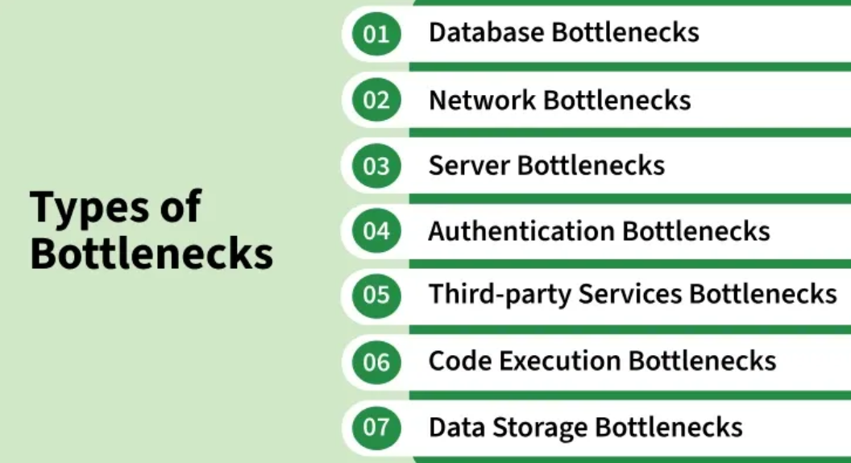
1. Database Bottlenecks
A database bottleneck occurs when database operations limit the performance of an application or system. It can result from inefficient queries, missing indexes, lock contention, high connection usage, or limited database resources.
- Slow queries can increase response times and reduce the number of requests the database can process.
- Poor indexing or inefficient query patterns can increase the amount of data the database needs to scan.
- High CPU, memory, or connection usage can further limit database performance.
Example: If an e-commerce website receives a large number of orders during a sale, inefficient queries for retrieving product or order information can slow down the database and delay request processing.
2. Network Bottlenecks
Network bottlenecks can significantly hinder scalability in a distributed system. It happen when a certain resource or component restricts a computer network's capacity or performance, which slows down or degrades the system's overall performance.
- They can occur at various points in a network topology and can severely impact the efficiency and responsiveness of an application or system.
- These bottlenecks occur due to bandwidth limitations, high latency, packet loss, congestion, or inefficient network topology.
Example: A video streaming service may encounter network bottlenecks if it doesn't have adequate content delivery infrastructure. Users may experience buffering or low-quality video streams when too many requests strain the network.
3. Server Bottlenecks
When the application server is unable to manage more requests or concurrent connections, a server bottleneck occurs. Limitations in server resources, including CPU, RAM, or disk I/O, may be the cause of this.
- Consider a social media site where an unexpectedly popular post causes a huge surge in users attempting to access it at once.
- If the server lacks the necessary resources to handle this surge, it may become unresponsive, degrading the user experience.
Example: You have a web application that allows users to upload and process images. As the user base grows, the server begins to experience performance issues. The server's CPU becomes a bottleneck because the image processing algorithm used by the application is computationally intensive, causing delays in image processing and overall sluggishness of the application.
4. Authentication Bottlenecks
Authentication is essential for securely verifying user identities and controlling access to system resources. An authentication bottleneck occurs when this process becomes slow or overloaded, affecting overall system performance and user experience.
- Caused by high volumes of login requests or inefficient authentication mechanisms.
- Can result from limited infrastructure or poorly optimized authentication workflows.
Example: An e-banking application may experience authentication bottlenecks during peak usage times, causing login delays if the authentication system cannot keep up with the volume of incoming requests.
5. Third-party Services Bottlenecks
For many features, such as cloud storage, geolocation, and payment processing, modern apps frequently rely on third-party services, which limits a system's overall performance, dependability, and scalability.
- A number of things, such as the third-party service's availability, response latency, rate limitations, or API modifications, might cause these bottlenecks.
- Identifying and addressing third-party services bottlenecks is crucial for designing systems that can provide consistent and responsive user experiences.
Example: If a ride-sharing app depends on an external mapping service and that service experiences downtime or slow response times, it can affect the app's performance and scalability.
6. Code Execution Bottlenecks
A code execution bottleneck occurs when inefficient algorithms, excessive CPU usage, runtime overhead, or inefficient synchronization limit application performance.
- Inefficient algorithms can increase the amount of computation required as the workload grows.
- Excessive CPU usage, unnecessary processing, locking, or synchronization can slow down request processing.
- Optimizing algorithms and reducing unnecessary computation can help improve application performance and scalability.
Example: An application that repeatedly processes a large dataset using an inefficient algorithm may consume excessive CPU resources, increasing response times as the workload grows.
7. Data Storage Bottlenecks
A data storage bottleneck occurs when the underlying storage system cannot provide sufficient capacity, throughput, or I/O performance for the workload.
- High disk I/O or storage latency can slow down applications that frequently read or write data.
- Insufficient storage throughput can limit the rate at which data can be processed.
- Limited storage capacity can prevent a system from accommodating growing data volumes.
Example: If a cloud-based file-sharing platform receives a large number of file uploads, insufficient storage throughput can slow down file uploads and retrievals, affecting the platform's performance.
Redundancy in System Design
Redundancy is the practice of adding backup components, resources, or processes to a system to ensure it continues operating even when failures occur. It improves system reliability, availability, and fault tolerance by minimizing downtime.
- Backup servers, network links, or storage systems can take over when the primary component fails.
- Duplicate copies of data help prevent data loss and ensure recovery during hardware or software failures.
Example: A website may use a secondary server that automatically handles requests if the main server crashes. Similarly, cloud services often store multiple copies of data across different locations to ensure availability.
Types of Redundancies
1. Hardware Redundancy
In order to guarantee system availability in the event of a failure, hardware redundancy involves replicating essential hardware components.
Example: Data is redundantly stored on several hard drives in a RAID (Redundant Array of Independent Disks) setup. Data can still be recovered from the other drives in the event that one fails.
2. Software Redundancy
In order to guarantee continuous operation, software redundancy depends on several instances of an application or service running concurrently.
Example: Software load balancers are frequently used by web servers to split up incoming requests among several server instances. The load balancer reroutes traffic to servers that are in good condition in the event that one fails.
3. Data Redundancy
Data Redundancy involves storing the same data in multiple locations or using replication techniques to ensure data availability.
Example: Database Replication creates redundant copied of database across multiple servers. If one server fails, another can continue serving the same data.
4. Network Redundancy
Network Redundancy provides multiple network paths or connections to ensure network availability and fault tolerance.
Example: BGP (Border Gateway Protocol) routing uses multiple network paths to reroute traffic in case of network failures, ensuring data can still flow.
5. Geographic Redundancy
In order to guard against natural disasters or outages that are unusual to a given region, geographic redundancy involves setting up redundant systems or data centers in various geographic regions.
Example: A global cloud service provider maintains data centers in multiple continents to ensure service availability even in the event of a regional disaster.
Active and Passive Redundancy
1. Active Redundancy
When two or more entities are performing the same task simultaneously, this is known as active redundancy. To keep things going smoothly, the others step in immediately if one of them is unable to perform the task.
Example: Think of a website with two servers working together. They both show the website to people. If one server has a problem, the other sever quickly takes over to make sure the website keeps running without any issues.
2. Passive Redundancy
Passive redundancy is similar to having a backup that is inactive until it is required. It remains silent in the background, just ready to jump in and assist when an issue arises.
Example: In computer networks, you can have a spare or backup router. The backup doesn't do any work until main router has a problem. When main one fails, the spare router starts working to keep the network connected.
Role of Load Balancing in Redundancy
Load Balancing plays a crucial role in Redundancy by ensuring that multiple servers or resources are utilized effectively. This helps enhance reliability and ensures that if ones server fails, other can seamlessly take over, keeping the system operational and reducing downtime.
Examples:
- A web application distributing user requests across multiple web servers.
- A DNS server using round-robin load balancing algorithm to distribute requests to multiple IP addresses for a single domain.
Failover Mechanisms
Failover Mechanisms are essential for ensuring uninterrupted service, when a component within a redundancy system fails. These mechanisms automatically detect failures and switch to a redundant component.
Example:
- Sever Failover: When a web server fails, a load balancer redirects traffic to a backup server.
- Database Failover: In database clusters, a primary database server failure triggers the promotion of standby server to primary role.
Testing and Validation for Redundancy
Testing and Validation are critical to ensure that redundancy mechanisms work as expected. These include:
- Redundancy Testing: Simulating failures to verify that redundant components and failover mechanisms function correctly.
- Validation Testing: Ensuring the data synchronization and consistency are maintained in redundant systems.
- Load Testing: Assessing how the system performs under heavy loads to identify potential bottlenecks and ensure that load balancing is effective.
Metrics for measuring Redundancy
Measuring the effectiveness of redundancy and fault tolerance is crucial. Common metrics include:
1. Mean Time Between Failures (MTBF)
Measures the average time between component failures.
MTBF = Total Operating Time / Number of Failures
Example: Let's say you have a server that has been running continuously for 1,000 hours, and it has experienced 2 failures during that time.
MTBF = 1,000 hours / 2 failures = 500 hours per failure
So, the MTBF for this server is 500 hours per failure. This means that, on average, you can expect this server to operate for approximately 500 hours before it encounters a failure. It's a measure of the system's reliability. The higher the MTBF, the more reliable the system.
2. Mean Time to Recovery (MTTR)
Measures the average time it takes to recover from a failure.
MTTR = Total Downtime / Number of Failures
Example: Suppose you have a network router that experienced downtime of 4 hours due to a failure, and this happened 2 times in a month.
MTTR = 4 hours / 2 failures = 2 hours per recovery.
This means that, on average, it takes 2 hours to restore the network router to full operational status each time it encounters a failure. A lower MTTR indicates that system can recover more quickly.
3. Availability:
Availability represents the percentage of time a system is operational.
Availability = (Total Uptime / Total Time) * 100%
Example: In a year, a data center was operation for 8,760 hours and had 50 hours of downtime.
Availability = (8,760 hours / (8,760 hours + 50 hours)) * 100 % = 99.43%
So, the availability of the data center is approximately 99.43%. Highly availability is usually desirable for critical systems because it indicates that they are reliable and accessible to users for the majority of the time.
4. Resource Utilization:
Evaluates the efficiency of resource usage in redundant components.
Resource Utilization = (Resource Usage / Total Available Resources) * 100%
Example: Let's say a redundant set of servers collectively uses 200 GB out of 500 GB if available storage space.
Resource Utilization = (200 GB / 500 GB) * 100 % = 40%
The resource utilization for this storage system is 40%.
Real-life Applications of Redundancy
Redundancy is widely used in critical industries to ensure continuous operation, reliability, and protection against failures.
- Finance: Banks use redundant servers and backup systems to ensure that banking services remain available even during hardware failures or system outages.
- Healthcare: Hospitals implement data backups and replication mechanisms to keep patient records accessible and recoverable in case of data loss or corruption.
- Aviation: Aircraft use redundant components, such as backup fuel pumps and ignition systems, to maintain safe operation if a primary system fails.
- Telecommunications: Telecom providers deploy redundant network paths and load-balancing systems to ensure uninterrupted communication services during network failures.
Difference between Redundancy and Replication
Both redundancy and replication improve system reliability and availability, but they achieve this in different ways.
Redundancy | Replication
Adds backup hardware, software, or resources to handle failures. | Creates identical copies of data or systems across multiple locations.
Primarily focuses on improving system reliability and fault tolerance. | Primarily focuses on improving data availability, consistency, and scalability.
Backup components become active when the primary component fails. | Multiple copies can be accessed simultaneously by users or applications.
Example: Multiple power supplies in a server. | Example: A database replicated across several servers.

